Name ____________________________________________________________________________________ Hour ________________

DNA---Teacher Notes

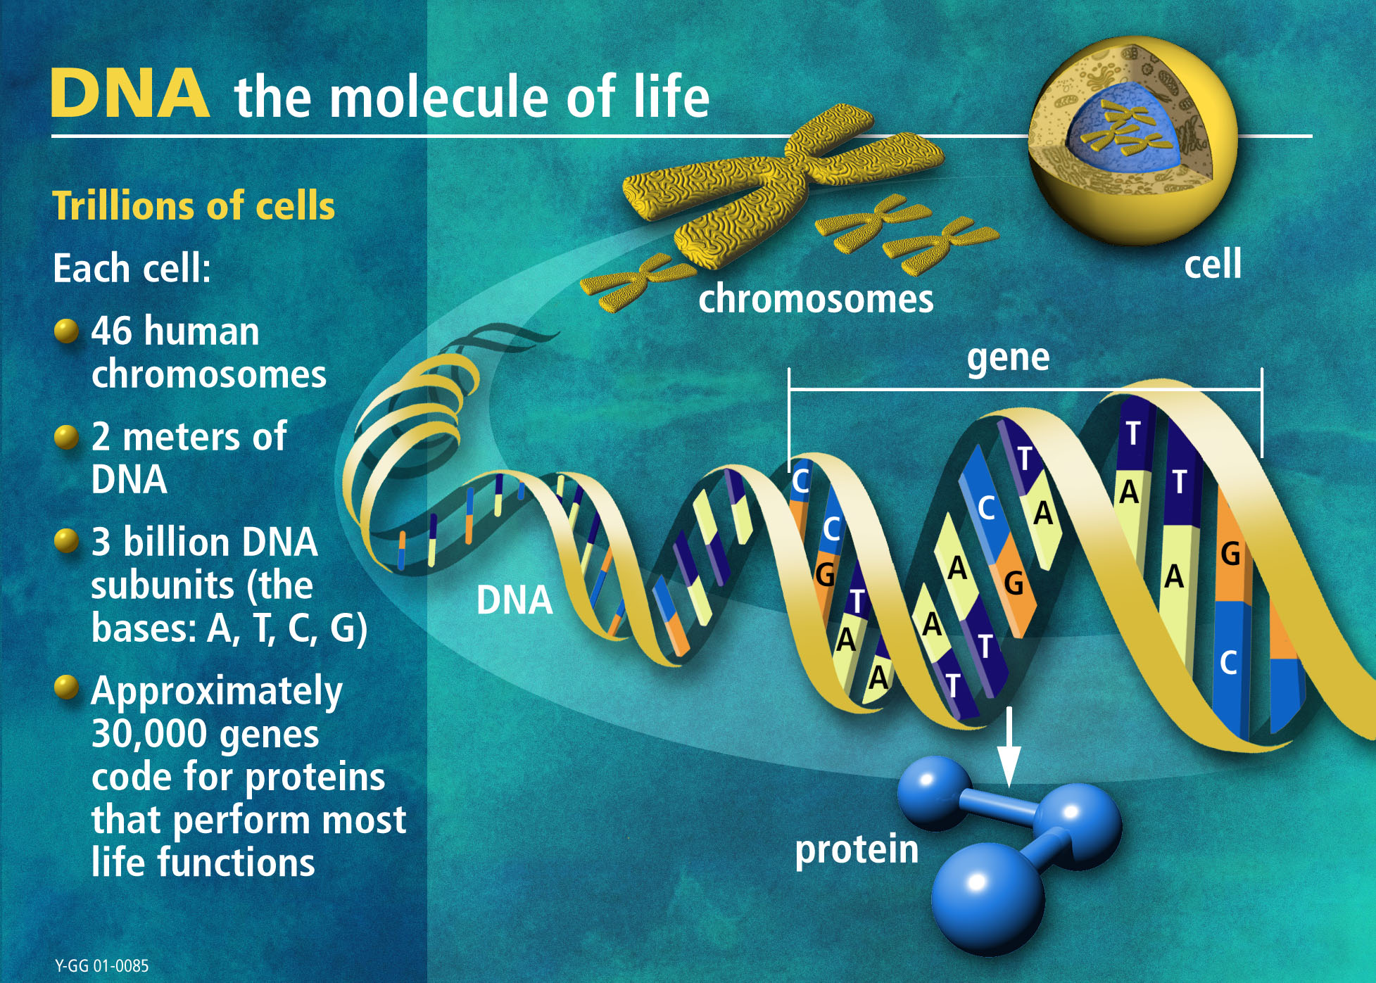

- DNA is located in the nucleus of a cell

- Each DNA molecule in a cell forms 1 chromosome.

- Chromosomes are made of DNA and protein.

- Genes are sections of chromosomes that code for specific traits that can be inherited.

DNA
A DNA molecule is a double helix----two strands twisted around each other like a spiral staircase.

Each strand is made of linked nucleotides.

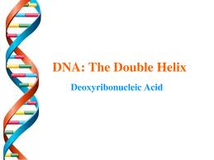
___________________________________________________________________________________________
Nucleotides—the subunits of DNA
DNA is made of nucleotides

A nucleotide consists of three different types of material.

- a phosphate
- a sugar (deoxyribose)
- a nitrogen base

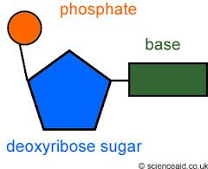

___________________________________________________________________________________________
Nitrogen bases
Nucleotides are identical except for the base.

There are 4 nitrogen bases.
- Adenine (A)
- Thymine (T)
- Cytosine (C)
- Guanine (G)
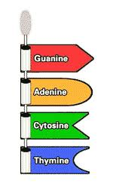
Nucleotides bond together
Each nitrogen base has a slightly different shape.

Adenine can only bond with thymine.

Cytosine can only bond with Guanine.

The nitrogen bases hook together with hydrogen bonds.
to form DNA

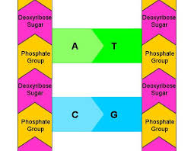
___________________________________________________________________________________________
Proteins
Proteins are long strings of amino acids.

___________________________________________________________________________________________
Gene
Each gene is a set of instructions for making proteins.

___________________________________________________________________________________________
Why Proteins?
Proteins determine your traits.

Each gene spells out specific sequences of amino acids for a specific protein.

Proteins are the reason for the different shapes, sizes, colors, and textures found in living things, such as antlers, claws, hair, and skin.

___________________________________________________________________________________________
Ribosomes
Ribosomes are where proteins are made.

How is RNA different
RNA, like DNA is a nucleic acid but it is different in 3 ways.

- RNA is one nucleotide chain instead of two.

- RNA contains the nitrogen base uracil instead of thymine.

- RNA contains the sugar ribose instead of deoxyribose.

from DNA

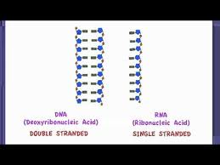

___________________________________________________________________________________________
Types of RNA
There are three main types of RNA, all of which are involved in making proteins.

- Messenger RNA (mRNA) copies the genetic instructions from the DNA in the nucleus, and carries the instructions to the ribosomes in the cytoplasm.

- Ribosomal RNA (rRNA) helps form ribosomes, the place where proteins are assembled.

- Transfer RNA (tRNA) brings amino acids to ribosomes, where they are joined together to form proteins.

Central Dogma of
DNA contains instructions for making a protein.

These instructions are copied by RNA.

RNA then uses the instructions to make a protein.

DNA ➔ RNA ➔ Protein
Molecular Biology

___________________________________________________________________________________________
Protein Synthesis
The process in which cells make proteins is called protein synthesis.

Protein synthesis consists of two processes:
- transcription
- translation

___________________________________________________________________________________________
Transcription
Transcription is the transfer of genetic instructions in DNA to mRNA.

During transcription mRNA is made.

This happens in the nucleus.

__________________________________________________________________________________________
Translation
- mRNA leaves the nucleus and travels to a ribosome which is made of rRNA and protein.

- Molecules of tRNA bring amino acids to the ribosome in the correct sequence.

- A protein is made.

Mutation
A change in the sequence of bases in DNA or RNA is called a mutation.

Everyone has mutations.

Mutations are essential for evolution to occur. They are the ultimate source of all new genetic material in a species.

__________________________________________________________________________________________
Types of Mutations
- deletion---sometimes a base is left out.

- substitution---an incorrect base replaces a correct base.

- insertion---an extra base is added in

___________________________________________________________________________________________
Consequences of a mutation
- improvement
- neutral (no change)
- harmful change

If a mutation happens in sex cells (Eggs or Sperm) (gametes) it can be passed on from one generation to the next.

If it happens in normal body cells, it will not be passed to offspring.

Causes of Mutations
Some mutations seem to happen spontaneously without any outside influence. They occur when mistakes are made during DNA replication or transcription.

Other mutations are caused by environmental factors called mutagens.

Examples of mutagens:

UV Radiation from natural sunlight and tanning beds

X-Rays

Cigarette Smoke

Nitrate and Nitrate Preservatives found in hot dogs and other processed meats

Benzoyl Peroxide a common ingredient in acne products

Barbecuing creates mutagenic chemicals in foods

___________________________________________________________________________________________
Mutagen
Anything in the environment that can cause a mutation is known as a mutagen.

