Scientific Inquiry (Unit 1)

1. The process of scientific inquiry...
a. | is a systematic investigation in search of an answer.
b. | is not important to the study of biology.
c. | is a long process that is useless
d. | is a way to prove your results.

2. Which of the following is not one of the seven steps of scientific inquiry?
a. | Forming a Hypothesis
b. | Identifying Variables
c. | Applying for money for your experiment.
d. | Keeping variables constant so that you only test the I.V.

3. This is what you alter/change in your experiment (the cause).
a. | Independent Variable (IV) | c. | Constant
b. | Dependent Variable (DV) | d. | Control Group

4. In your data table, the Dependent Variable is always on the right, but what goes on the left?
a. | Independent Variable | c. | The Constants
b. | The Outcome | d. | Nothing

5. Why must you average or eliminate the independent variable in one of your groups?
a. | To see if you got the right results.
b. | To make sure you did everything right.
c. | To make it easier to test.
d. | To be able to compare your test group (results).

6. Which of the following would be a piece of laboratory equipment?
a. | Pen and Paper | c. | Plant
b. | Water | d. | Stop Watch

7. In order to see if there is a change in an experiment, what is the name of the group that you use to compare your results to?
a. | Constant Group | c. | Independent Group
b. | Control Group | d. | Dependent Group

8. This is what you measure and record during the experiment (the effect).
a. | Independent Variable (IV) | c. | Dependent Variable (DV)
b. | Constant | d. | Control group

9. What is the most important reason that your procedures be clear, specific, and repeatable?
a. | You get the right results. | c. | You can read them.
b. | Your research is valid. | d. | Other people can read them.

10. In order to see if there is a change in an experiment, what is the name of the group that you use to compare your results to?
a. | Independent Group
b. | Dependent Group
c. | Constant Group
d. | Control Group

Ecology (Unit 2)

11. Polar bears swim across large expanses of ocean while hunting for seals, their main source of food.
The bears use sea ice as resting spots during their long swims. However, the sea ice is rapidly melting as a result of global warming. Which statement describes what most likely will happen if global warming continues at its present rate?

a. | Polar bears and seal populations will both increase.
b. | Polar bear populations will decrease, and seal populations will increase.
c. | Polar bear populations will increase, and seal populations will decrease.
d. | Polar bear populations will decrease, and seal populations will remain the same.

12. A forest fire destroys the majority of the trees in a state park. Which effect will this most likely have on secondary consumers in that ecosystem?

a. | The amount of available energy will increase because there will be fewer predators in the forest.
b. | The amount of available energy will increase becuase there will be less competition from producers.
c. | The amount of available energy will decrease because fewer primary consumers will survive the lack of vegetation.
d. | The amount of available energy will remain constant because secondary consumers are not reliant on primary consumers.

13. A new species of snake was introduced to a tropical region. Scientists then noticed a steady decline in the presence of field mice and in increase in the number of snakes. Which of these is the most likely explanation about why the population size of each animal changed?

a. | The snakes introduced to the region dominated the habitat, forcing the mice to find another place to live.
b. | The mice became prey to the introduced snakes, allowing the snake population to increase but decreasing the mice population.
c. | The snakes introduced to the region competed with the mice for food, allowing the snake population to increase but decreasing the mice poupulation.
d. | The people in the surrounding area set traps that killed mice, allowing the snakes to live without an predators and therefore to increase in number.

Population Growth Over Time
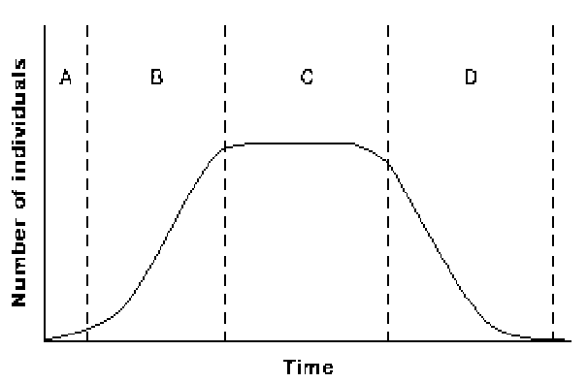

14. Refer to the illustration above. Which time period shows exponential growth of the population?
a. | period A | c. | period C
b. | period B | d. | period D

15. Refer to the illustration above. During which time period are the birth rate and death rate equal?
a. | period A | c. | period C
b. | period B | d. | period D

16. One species of Galapagos finches, the cactus finch, eats insects off cactus plants. A disease kills off most of the cacti in the Galapagos Islands. Which of these most likely would happen to the carrying capacity of the island?

a. | It would increase a small amount since the insect population would decrease.
b. | It would remain about the same since the finches would change to a different diet.
c. | It would increase exponentially since the insects would have limited places to hide.
d. | It would decrease considerably since the finches are specifically adapated to their niche.

17. As a population reaches its carrying capacity, there is an increase in competition for
a. | food.
b. | shelter.
c. | mates.
d. | All of the above

18. If the niches of two organisms overlap,
a. | the organisms may have to compete directly.
b. | the two organisms will always form a symbiotic relationship.
c. | both organisms will disappear from the habitat.
d. | one organism usually migrates to a new habitat.

19. 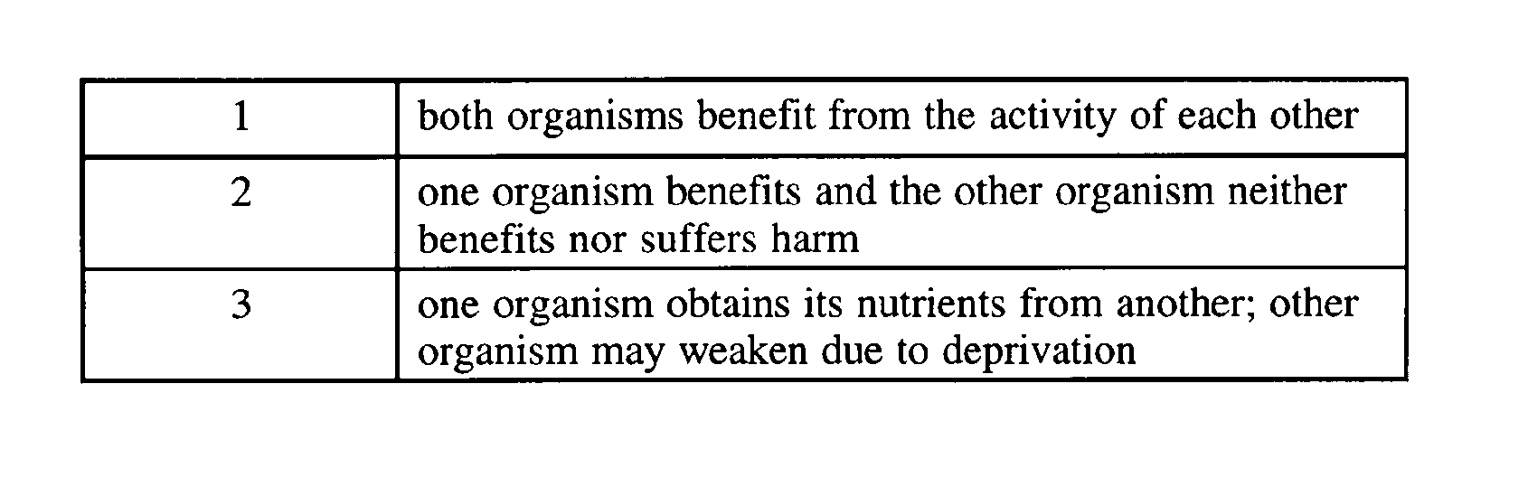
Refer to the table above. The table represents three types of
a. | competition. | c. | symbiosis.
b. | rhythmic patterns. | d. | secondary succession.

20. When the skunk lives in an abandoned woodchuck’s hole, this is an example of what?
a. | commensalism. | c. | mutualism.
b. | competition. | d. | parasitism.

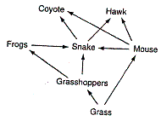

21. Refer to the food web above, the amount of available energy in the entire food web would decrease if which organism was removed?
a. | Coyote | c. | Snake
b. | Grasshoppers | d. | Grass

22. Refer to the food web above, What percentage of the energy that the grass gets from the sun is available to the grasshoppers?
a. | 150% | c. | 10%
b. | 90% | d. | 50%

23. Refer to the food web above, Which organism is a primary producer?
a. | Grass | c. | Grasshopper
b. | Frogs | d. | Hawk

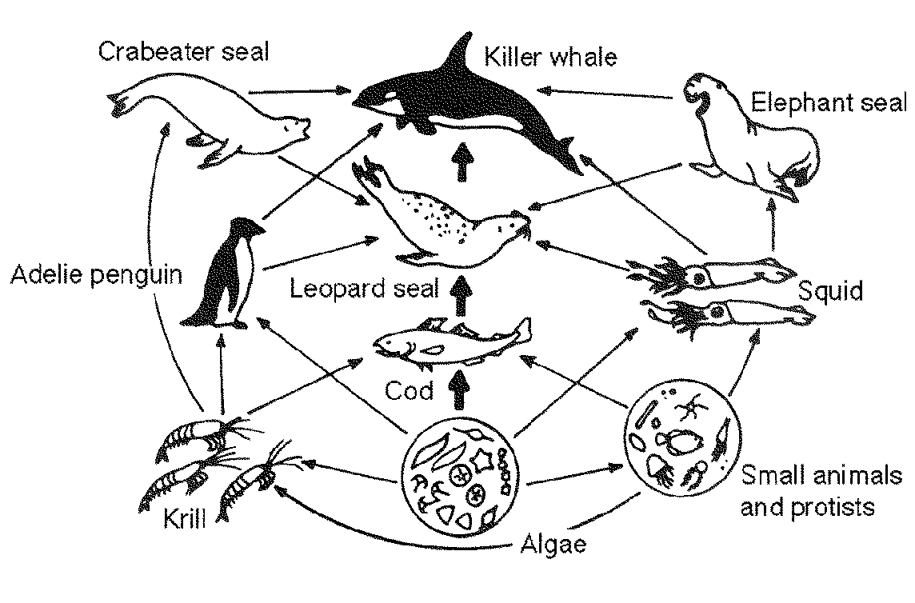

24. Refer to the illustration above. What is one creature that the Squid eats?
a. | Leopard Seal | c. | Elephant Seal
b. | Killer Whale | d. | Algae

25. Refer to the illustration above. What percentage of the Sun’s energy will the Small Animals/Protists recieve when they eat the Algae?
a. | 0% | c. | 50%
b. | 10% | d. | 100%

26. Refer to the illustration above. Which of the following is a predator of the Penguin?
a. | Cod | c. | Crabeater Seal
b. | Leopard Seal | d. | Krill

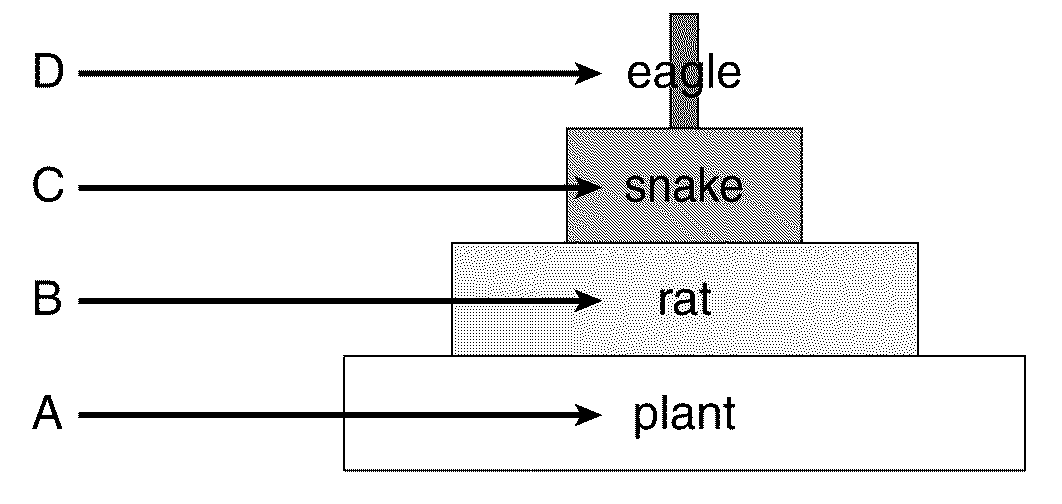

27. Refer to the illustration above. How much energy is available to the organisms in level C?
a. | all of the energy in level A plus the energy in level B
b. | all of the energy in level A minus the energy in level B
c. | 10 percent of the energy in level B
d. | 90 percent of the energy in level B

28. Refer to the illustration above. The energy that is lost between each trophic level is lost as
a. | heat | c. | water
b. | oxygen | d. | nitrogen

29. If one species in a food chain were killed what would happen to all of the other species in the above trophic levels?
a. | The species in higher trophic levels would decrease.
b. | The species in higher trophic levels would increase.
c. | Nothing would happen to the other species.
d. | The species in lower trophic levels would decrease.

Biomolecules (Unit 3)

30. The two types of nucleic acids are
a. | chlorophyll and retinal. | c. | lipids and sugars.
b. | DNA and RNA. | d. | glucose and glycogen.

31. Which of the following is a substance processed through a biogeochemical cycle?
a. | protein | c. | water
b. | salt | d. | carbohydrate

32. Which of the following is not an organic macromolecule?
a. | carbohydrate | c. | lipid
b. | ice | d. | nucleic acid

33. All biomolecules contain
a. | carbon | c. | calcium
b. | nitrogen | d. | sodium

34. Biomolecules are also known as
a. | Macromolecules | c. | Mitochondria
b. | Cells | d. | Polymolecules

35. Which type of molecule forms a lipid bilayer within a cell membrane?
a. | phospholipid | c. | protein
b. | nucleic acid | d. | carbohydrate

36. Why is turgor (water) pressure important to cells?
a. | It gives cells shape and structure.
b. | It provides hydration for plants.
c. | Without turgidity plants wilt.
d. | All of the above.

37. A molecule can easily pass through the selectively permeable membrane of an animal cell. Which of these most likely describes the molecule?

a. | The molecule is very small and charged
b. | The molecule is very large and charged
c. | The molecule is very small and not charged
d. | The molecule is very large and not charged

38. What is the main function of a selectively permeable cell membrane?
a. | storage of water
b. | storage of chemicals
c. | breaks down molecules within the cell
d. | regulates what enters and what leaves the cell

39. Water is important to cells because
a. | It provides soluble environment for chemical reactions.
b. | It acts as a buffer for body temperature.
c. | It helps determine the shape of proteins.
d. | All of the above

40. The shape of a protein is primarily determined by
a. | Where it is at in the cell.
b. | The type and sequence of its amino acids.
c. | If it interacts with oxygen.
d. | None of the above.

41. An enzyme
a. | is not used up when catalyzing a reaction.
b. | lowers the activation energy of a reaction.
c. | bonds with a substrate molecule at the enzyme’s active site.
d. | All of the above

Cell Structure and Function (Unit 4)

42. The mitochondria is used
a. | to produce ATP. | c. | as a receptor protein.
b. | to package proteins | d. | to transport

43. Which structure is primarily responsible for directing all processes of a plant cell?
a. | chloroplast | c. | mitochondria
b. | lysosome | d. | nucleus

44. A cell that requires a lot of energy might contain large numbers of
a. | chromosomes. | c. | mitochondria.
b. | vacuoles. | d. | lysosomes.

45. Plant cells have a large membrane-bound space in which water, waste products, and nutrients can be stored. This space is called the
a. | mitochondrion. | c. | vacuole.
b. | chloroplast. | d. | Golgi apparatus.

46. The Golgi Apparatus is an organelle that
a. | Receives, packages, and delivers proteins from the E.R.
b. | Supplies energy to the cell.
c. | Receives and delivers proteins from the mitochondria.
d. | Acts as the brain of the cell.

47. One difference between prokaryotic cells and eukaryotic cells is that
a. | mitochondria are found in prokaryotic cells.
b. | prokaryotes do not have a nucleus.
c. | prokaryotes are multicellular.

48. A structure within a eukaryotic cell that performs a specific function is called a(n)
a. | organelle. | c. | tissue.
b. | organ tissue. | d. | biocenter.

49. The double membrane surrounding the nucleus is called the
a. | nucleolus. | c. | ribosome.
b. | cell wall. | d. | nuclear envelope.

50. In a cell, proteins are made on
a. | the mitochondria. | c. | the nucleus.
b. | ribosomes. | d. | the cell membrane.

51. The Golgi Apparatus is an organelle that
a. | receives proteins and lipids from the endoplasmic reticulum.
b. | packages molecules made in the endoplasmic reticulum.
c. | is involved in the distribution of proteins.
d. | All of the above
e. | None of the above

Cell Transport (Unit 5)

52. Molecules that go against a concentration gradient are using what type of transport?
a. | Active | c. | Isotonic
b. | Passive | d. | Diffusion

53. The diffusion of water into or out of a cell is called
a. | solubility. | c. | selective transport.
b. | osmosis. | d. | endocytosis.

54. Molecules that are too large to be moved across a cell membrane can be REMOVED from the cell by
a. | diffusion. | c. | endocytosis.
b. | exocytosis. | d. | osmosis.

55. Molecules that are too large to be moved across the membrane can be transported INTO the cell by
a. | osmosis.
b. | endocytosis.
c. | exocytosis.
d. | diffusion.

56. Does it take energy to go down a concentration gradient?
a. | Yes
b. | No

57. If a cell is placed into an isotonic environment, which way will water move?
a. | Into the cell
b. | Out of the cell
c. | Into and Out of the cell
d. | None of the above

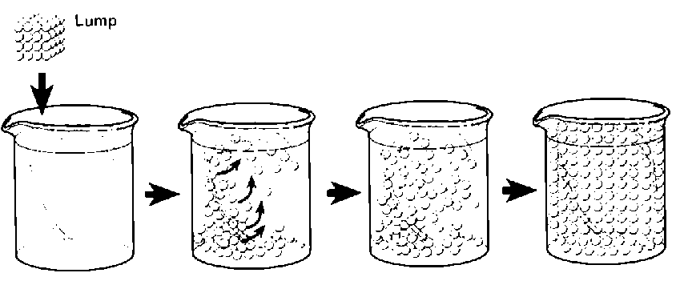

58. Refer to the illustration above. The process of a lump of sugar dissolving in a beaker of water to reach equilibrium is called what?
a. | osmosis.
b. | exocytosis.
c. | active transport.
d. | diffusion.

59. What type of solution will cause a cell to swell if it is placed into it?
a. | hypotonic solution.
b. | hypertonic solution.
c. | isotonic solution.
d. | None of the above

60. What is the main reason particles diffuse (the end result of diffusion)?
a. | to remain greater inside a membrane.
b. | eventually becomes equal on both sides of a membrane.
c. | to remain greater outside of a membrane.
d. | to become unbalanced on both sides of a membrane.

61. Active transport...
a. | requires energy.
b. | moves substances down their concentration gradient.
c. | does not involve carrier proteins.

Photosynthesis/Cell Respiration: Energy Conversion (Unit 6)

62. The major atmospheric by-product of photosynthesis is
a. | nitrogen. | c. | water.
b. | carbon dioxide. | d. | oxygen.

63. Cells produce ATP the best (most efficiently) when in the presence of
a. | water. | c. | oxygen.
b. | carbon dioxide. | d. | protein.

64. Although photosynthesis does make some ATP, which process do autotrophs use to make most of their energy?
a. | exocytosis. | c. | photosynthesis.
b. | cellular respiration. | d. | eating food.

65. The beginning reactants of photosynthesis are:
a. | Water and Glucose | c. | Water and Carbon Dioxide
b. | Water and Oxygen | d. | Carbon Dioxide and Glucose

66. Which of these would lead to a lower rate of photosynthesis in a plant?
a. | an increase in the amount of oxygen in the air
b. | a decrease in the amount of oxygen in the air
c. | an increase in the amount of carbon dioxide in the air
d. | a decrease in the amount of carbon dioxide in the air

67. Which statement describes a way in which cellular respiration differs from photosynthesis?
a. | Cellular respiration consists of two phases
b. | Cellular respiration releases carbon dioxide
c. | Cellular respiration provides energy for the cell
d. | Cellular respiration is carried out in one specific organelle.

68. When cells break down food molecules, energy is
a. | released all at once.
b. | released entirely as body heat into the environment.
c. | temporarily stored in ATP molecules.
d. | None of the above

69. Which of these best explains the difference between the way animals and plants exchange gases with their environment?
a. | Animals use only photosynthesis, while plants use both photosynthesis and respiration.
b. | Animals use only respiration, while plants use both photosynthesis and respiration.
c. | Animals use both photosynthesis and respiration, while plants use only respiration.
d. | Animals use both photosynthesis and respiration, while plants use only photosynthesis.

Cell Division & Reproduction: Mitosis & Meiosis (Unit 7)

70. Which process allows for an organism to increase the number of body cells during development?
a. | budding | c. | meiosis
b. | interphase | d. | mitosis

71. Mitosis is a process by which
a. | The chromosomes of a cell are divided in half.
b. | Sex cells are made.
c. | The nucleus of a cell divides into two identical cells.

72. What is the result of the fertilization of an egg?
a. | It restores the diploid number of chromosomes.
b. | It passes on a full set of chromosomes from each parent.
c. | It gives offspring more chromosomes than the parents.
d. | It gives offspring fewer chromosomes than the parents.

73. Which statement best describes an advantage of asexual reproduction for a population of organisms?
a. | The population can increase in number more quickly.
b. | The population can develop greater genetic diversity.
c. | The population can maintain the same number of organisms.
d. | The population can adapt more quickly to a changing environment.

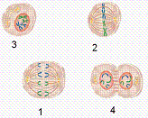

74. Refer to the illustration above. What is the correct order of Mitosis?
a. | 1, 2, 3, 4 | c. | 3, 2, 4, 1
b. | 4, 3, 2, 1 | d. | 3, 2, 1, 4

75. Refer to the illustration above. The cell in diagram 1 is in what phase of mitosis?
a. | metaphase. | c. | anaphase.
b. | telophase. | d. | prophase.

76. Refer to the illustration above. Which cell diagram refers to prophase?
a. | 1
b. | 2
c. | 3
d. | 4

77. Refer to the illustration above. Which phase above shows the chromosomes moving apart and going to opposite poles?
a. | 1
b. | 2
c. | 3
d. | 4

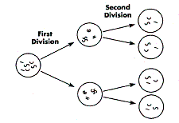

78. Refer to the illustration above. The process shown is
a. | mitosis | c. | mutation
b. | meiosis | d. | dominance

79. Two gametes containing 20 chromosomes fuse during fertilization. How many chromosomes will the zygote cell contain?
a. | 10
b. | 20
c. | 40
d. | 60

Mendel Genetics (Unit 8)

80. In a certain insect, round wings (R) are dominant to pointed wings (r). Which cross will produce the greatest number of genotypic and phenotypic variations?
a. | rr x rr | c. | Rr x RR
b. | Rr x Rr | d. | RR x RR

81. homozygous : heterozygous ::
a. | dominant : recessive | c. | same: different
b. | BB: bb | d. | allele: gene

82. A genetic trait that appears in every generation of offspring is called
a. | dominant. | c. | recessive.
b. | phenotypic. | d. | superior.

83. A change in a gene due to damage or being copied incorrectly is called
a. | evolution. | c. | segregation.
b. | meiosis. | d. | a mutation.

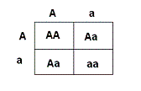

84. Refer to the Punnett Square above. How many different phenotypes do the offspring show?
a. | 1 | c. | 3
b. | 2 | d. | 4

85. Refer to the Punnett Square above. Does either parent have the recessive phenotype?
a. | Yes
b. | No

86. Refer to the Punnett Square above. How many different genotypes do the offspring show?
a. | 1 | c. | 3
b. | 2 | d. | 4

87. Which of the following is true about Sex-Linked traits?
a. | 100% of males that have the trait will be affected.
b. | 100% of the females that have the trait will be affected.
c. | Females cannot inherit X-linked traits.
d. | Color-blindness is a Sex-Linked trait.

88. Which of the following can you NOT determine just by looking at a dominant flower?
a. | color
b. | phenotype
c. | genotype

89. What did Mendel name the generation that he allowed to self-pollinate at the beginning (to make sure he started with true-breeding plants)?
a. | F₁ generation. | c. | P generation.
b. | F₂ generation. | d. | P₁ generation.

DNA & RNA: Molecular Genetics (Unit 9)

90. If you cross two heterozygous parents, what will be the genotypic ratio of the offspring?
a. | 4:0 | c. | 75% Dominant and 25% Recessive
b. | 1:2:1 | d. | 1:1

91. Which of the following is the correct order of how proteins are synthesized?
a. | Ribosomes Assemble Proteins, Protein Folds into Active Shape, DNA Codes Proteins
b. | Protein Folds into Active Shape, DNA Codes Proteins, Ribosomes Assemble Proteins
c. | DNA Codes Proteins, Ribosomes Assemble Proteins, Protein Folds into Active Shape

92. All of the following are true about the structure of DNA except
a. | DNA consists of two strands of nucleotides joined by hydrogen bonds.
b. | Short strands of DNA are contained in chromosomes inside the nucleus of a cell.
c. | Every DNA nucleotide contains a sugar, a phosphate group, and a nitrogen base.
d. | Long strands of nucleotides are twisted into a double helix.

93. A strand of DNA is exposed to intense heat. Which of these best describes what will happen to the strand of DNA?
a. | The chemical bonds of the DNA molecule will be broken.
b. | More nitrogen base pairs will add on to the DNA molecule.
c. | The chemical bonds of the DNA molecules will be strengthened.
d. | The nitrogen base pairs in the DNA molecule will swtich places.

94. What type of bonds hold together the nitrogen bases Adenine and Thymine in DNA?
a. | Double Hydrogen Bond | c. | Triple Hydrogen Bond
b. | Covalent Bond | d. | Peptide Bond

95. The chromosome structure in a cell accounts for genetic variation based on the order of its...
a. | sugar groups | c. | hydrogen bonds
b. | nitrogen bases | d. | phosphate groups

96. What is the role of hydrogen bonds in the structure of DNA?
a. | to connect the base pairs | c. | to separate the strands
b. | to synthesize proteins | d. | to code for proteins

97. Which of the following is not part of a nucleotide?
a. | nitrogen base | c. | phosphate group
b. | 5-carbon sugar | d. | nucleus

98. In DNA, adenine is equal to the number of thymine and….
a. | guanine : cytosine | c. | thymine: uracil
b. | adenine : DNA | d. | protein : DNA

99. Which of these shows the correct order of Protein Synthesis?
a. | RNA makes then DNA makes Protein. | c. | Protein makes then RNA makes DNA.
b. | DNA makes then RNA- makes Protein. | d. | Protein makes then DNA makes RNA.

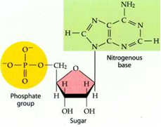

100.
The entire molecule shown in the diagram above is called a(n)
a. | pyrimidine. | c. | nucleotide.
b. | polysaccharide. | d. | amino acid.

Natural Selection & Evolution (Unit 10)

101. Natural selection is the process by which organisms with traits less suited to their environment....
a. | survive and reproduce at a greater rate than better adapted organisms in the same environment.
b. | survive and reproduce at a slower rate than better adapted organisms in the same environment.

102. The process by which a species becomes better suited to its environment is known as
a. | accommodation.
b. | variation.
c. | adaptation.

103. The fur color of a Red fox and an Artic Fox are different colors, this is an example of what?
a. | Rapid Mutation | c. | Natural Selection
b. | Codominance | d. | Random Occurance

104. We learned that the Theory of Evolution is supported by DNA/Blood Protein Evidence, the Fossil Record, Natural Selection, and Homologous Structures.
a. | True
b. | False

105. Which of the following is a vestigial structure?
a. | the human tailbone | c. | flower color
b. | the beak of a Finch | d. | thorns on roses

106. The fossil record shows that evolution takes place....
a. | rapidly.
b. | in only one place on Earth.
c. | gradually.

107. What would happen eventually if a species was unable to reproduce?
a. | The species would mutate. | c. | The species would become extinct.
b. | The species would increase. | d. | The species would continue to thrive.

108. The loss of habitat in a forest region has caused some plant species to become extinct, while others survive. The process is best explained by...
a. | natural selection | c. | biological magnification
b. | law of segregation | d. | alternation of generations

109. A population of salamanders that live in a river require clear, fresh water to survive. A flood causes tons of sediment to be suspended in the river. Which of these most likely will happen to the salamander population?
a. | The salamanders will adapt to life on land.
b. | The salamanders will move to another river.
c. | The salamanders will adapt to living in the muddy water.
d. | The salamanders will decrease in number because of the water quality.

110. The Loulu tree in Hawaii reproduces by a seed encased in a fruit. Non-native species, such as pigs and rats, eat the fruit as a regular part of their diet, drastically reducing the regeneration rate of the Loulu. What most likely would be the outcome for Loulu trees in the next century without intervention?
a. | They would become extinct.
b. | They would rebound and thrive.
c. | They would remain at their current levels.
d. | They would evolve a new way to reproduce.

