**STUDY GUIDE FOR:**

**Semester 1 Comprehensive Biology Final 2014-2015**

1. **As a result of diffusion, the concentration of many types of substances do what?**
2. **Diffusion is the movement of a substance from _________ to __________ concentration.**

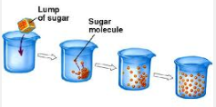

1. **Refer to the illustration above. The process shown is called**
2. **The diffusion of water into or out of a cell is called**
3. **A cell which is at equilibrium will gain turgidity when placed in what type of solution?**
4. **Proteins that act like selective passageways in the cell membrane are known as what kind of proteins?**
5. **What type of transport do *not* require energy?**
6. **List 3 types of active transport?**
7. **Molecules that are too large to be moved through the membrane can be transported into the cell by what kind of “cytosis”?**
8. **What is the main function of a selectively permeable cell membrane?**
9. **What type of transport uses ATP to move particles against the concentration gradient?**
10. **The sodium potassium pump requires what to move both sodium and potassium...**
11. **Vesicles move substances into and out of the cell during what type of transport?**
12. **Lipids are non-polar molecules. How would you expect them to enter and exit a cell?**
13. **Why is endocytosis NOT a type of passive transport?**
14. **Why is the sodium potassium pump active transport?**

**PROMPT**: Paramecia have star-shaped organelles, called contractile vacuoles, that expel excess water. The illustration below depicts a paramecium.



1. **Refer to the prompt above. If something happened to a paramecium (single-celled animal) that caused its cell membrane to stop working correctly, what would you expect to happen to the paramecium if it was suspended in a low salt concentration (hypotonic)?**



**A B C**

1. **Refer to the red blood cell illustration above. Which of the following illustrations depicts cells in a hypotonic environment?**

**Use the illustration below to answer the following three questions (below).**



**A B C**

1. **Which of the following beakers shown above depicts a hypertonic environment?**
2. **Based on the cell and the environment depicted in beaker B, in which direction will the most water move?**
3. **Which of the beakers depicts a cell and environment in which no net movement of water will occur?**

**Use the graph below to answer the following three questions (below):**

This graph is from data collected on shell-less eggs, which were placed in solutions of three different concentrations. The data shows the changes in egg weight over time.



1. **In the graph above, which of the following lines represents an egg that was placed in a hypotonic solution?**
2. **In the graph above, which of the following lines represents an egg that was placed in a hypertonic solution?**
3. **According to the graph above, which of the following lines represents an egg that was placed in an isotonic solution?**
4. **Active transport requires** _______________.
5. **What will happen if an animal cell that has a solute concentration of 1% is placed**

**in a 5% saltwater solution?**

1. **In simple diffusion, how do molecules enter or exit a cell?**

**Use the illustration below to answer the following three questions:**



**A B**

1. **Refer to the illustration above, which picture correctly depicts a cell carrying out endocytosis:**
2. **Refer to the illustration above, which picture correctly depicts a cell carrying out exocytosis:**
3. **Refer to the illustration above, the process shown above uses which membrane bound organelle to transport substances into and out of the cell?**
4. **Oxygen and carbon dioxide molecules pass freely through cell membranes without energy needed. What determines the direction that they will move.**

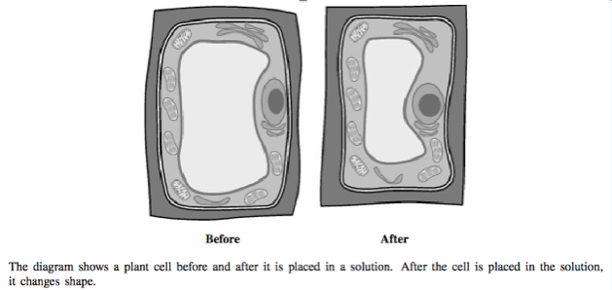

1. The cell was most likely placed into a solution with a ________% of salt than it was used to

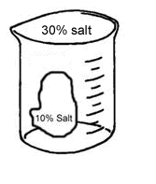

1. Describe what would happen to the cell placed into beaker to the right?
2. Count the number of water molecules (H20) around the cell and in the cell (before and after). Which way did water move (into or out of the cell)?

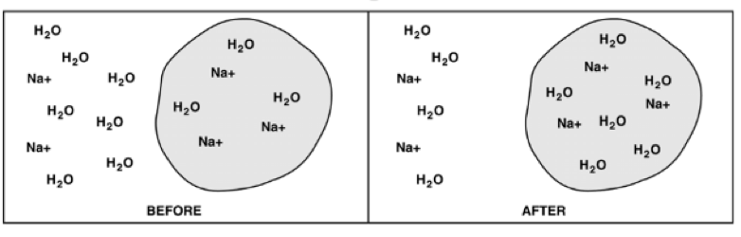

**Unit 4 (Cell Structure)**

1. Which structure is primarily responsible for directing all processes of a plant cell?
2. Which of these is the best model of a prokaryotic cell?

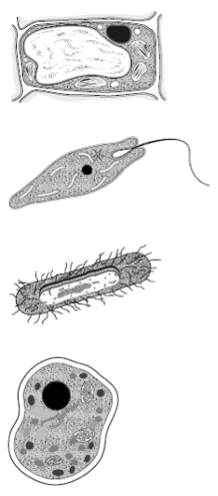




1. A cell that requires a lot of energy might contain large numbers of…
2. List 3 reasons you can classify a cell as a prokaryote?
3. What is the function of a cell’s membrane?

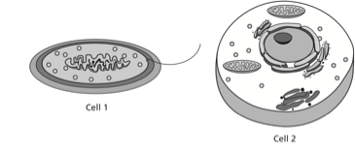

1. Which statement correctly identifies the cells above?
   1. Cell 1 is prokaryotic; cell 2 is eukaryotic
   2. Cell 1 is eukaryotic; cell 2 is prokaryotic
   3. Both cells are prokaryotic
   4. Both cells are eukaryotic
2. The smallest units of life are called ____________________.
3. A scientist treats a cell with a chemical that destroys the ribosomes. What biomolecule will the cell quit making?
4. Some organelles have their own DNA that is distinct from the cell’s nuclear DNA. This is true of which organelle?
5. Using the data table below, evaluate what data is being compared in testable question format.

|  |  |  |  |
| --- | --- | --- | --- |
| **Amount of Sugar (mg/100ml)** | **Height of Plant (cm)** | | |
| **Month 1** | **Month 2** | **Month 3** |
| **Plant 1**  **(10mg/100ml)** | **6** | **9** | **11** |
| **Plant 2**  **(20mg/100ml)** | **8** | **11** | **12** |
| **Plant 3**  **(30mg/100ml)** | **9** | **13** | **15** |
| **Plant 4**  **(40mg/100ml)** | **5** | **0**  **(Died)** | **0**  **(Died)** |
| **Plant 5**  **(0mg/100ml)** | **5** | **6** | **7** |

1. Which pair of structure best shows that plant cells have functions different from animal cells?
2. cytoplasm and mitochondria
3. ribosomes and cell membranes
4. chloroplasts and cell walls
5. chloroplasts and cell membranes
6. Which of these supports the cell theory as it is stated today?
7. Not all cells are alive.
8. New cells are produced by existing cells.
9. Cells must contain a nucleus.
10. All organisms are composed of more than one cell.

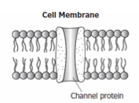

1. The diagram above shows a section of a cell membrane that includes a channel protein. The function of this protein is to…..
2. Susan finds some old celery in the refrigerator. When she picks it up, she finds that it is limp and bendable. She places the celery in a bowl of water for an hour. When she returns, she finds that the celery stalk is rigid/stiff. Which organelle in the cells of the celery is responsible for this change?
3. The structure in the illustration below is composed mainly of what two things?

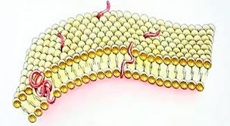

1. 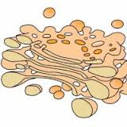 What is the name of the structure, in the photo below, that is pinching off of the golgi apparatus and is involved in exocytosis?

**Use Prompt 1 for the following questions:**

**Prompt 1. An investigation was designed to determine the effect of the amount of water on equal-sized bean plants of the same species. Plants were grown under identical conditions except for the amount of water they were given. One group was watered with 200 ml of water once a day, while the other group was watered with 400 ml of water once a day. After several days the heights of the plants were measured. It was determined that the plants watered with 400 ml of water showed more growth.**

1. **The *independent variable* in Prompt 1 is the**
2. **The *dependent variable* in Prompt 1 is the**

**Use Prompt 2 for the questions below.**

**Prompt 2: Mary thinks that her strawberry plants will grow better if she uses fertilizer.  She puts soil and fertilizer in Pot A.  It Pot B she puts soil and no fertilizer.  She plants the same number of seeds and the same type (strawberry) seeds in both pots.  She moves one of the pots closer to the window so it can get more sunlight.  She waits 6 weeks and measures the height of the strawberry plants.**

1. What is the constant in Mary’s experiment?
2. Which group is Mary’s control group?
3. In order to see if there is a change in an experiment, what do you **compare** your results to?

**Prompt 3: In one niche, a snake hides in a tree to avoid predators. A hippo scratches at its hind leg where a tick has bitten. The hippo allows a bird to fly onto its back in order to eat the parasites that are sucking the hippo’s blood. A zebra becomes lunch for a lion and two monkeys are working together to crack open a fruit for lunch.**

1. In the prompt above, which two animals show an example of mutualism?
2. The tick sucking the hippo’s blood.
3. The tree providing the snake camouflage.
4. The lion eating a zebra.
5. The bird removing ticks off of the hippo’s back.
6. In the prompt above, which two animals show an example of parasitism?
7. The tick sucking the hippo’s blood.
8. The tree providing the snake camouflage.
9. The lion eating a zebra.
10. The bird removing ticks off of the hippo’s back.
11. In the prompt above, which two animals show an example of commensalism?
12. The tree providing the snake camouflage.
13. The lion eating a zebra.
14. The bird removing ticks off of the hippo’s back.
15. In the prompt above, which two animals show an example of predator-prey?
16. The tick sucking the hippo’s blood.
17. The tree providing the snake camouflage.
18. The lion eating a zebra.
19. The bird removing ticks off of the hippo’s back.

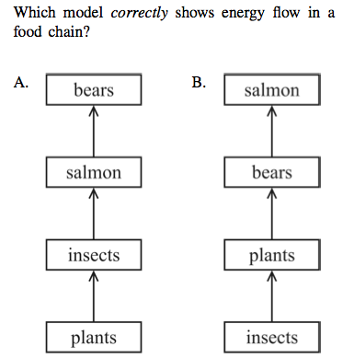

1. 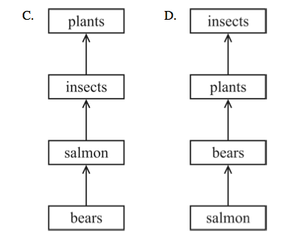

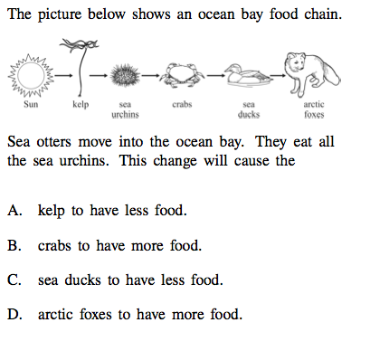

2. Which of the following conditions affects the rate of enzymes?
   1. pH
   2. heat
   3. enzyme concentration
   4. all of the above

1. Which of the following is **not** part of a nucleotide?
   1. Nitrogen base
   2. 5-carbon
   3. phosphate group
   4. nucleus
2. Carbohydrates and lipids are both used to do what in our bodies
3. Which statement is true about enzymes?
   1. Are biological catalysts
   2. Are not needed for life to exist
   3. Are made of long chains of carbohydrates
   4. None of the above
4. Why is water often called a “universal solvent”?
   1. It dissolves many materials.
   2. It surrounds most cells.
   3. It is a polar substance with unique properties.
   4. All of the above.
5. 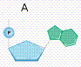Refer to the illustration to the right, figure A is a picture of what?

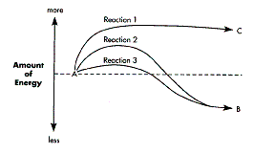

1. Refer to the illustration above. Why is reaction 3 faster than reaction 2?
2. Refer to the illustration above. Is Reaction 1 endothermic or exothermic?
3. Proteins are used in our bodies for what functions

Name:

Hour:

GLE 3.2.F.b Predict the movement of molecules across a selectively permeable membrane needed for a cell to maintain homeostasis given concentration gradients and different sizes of molecules. (Unit 5) 1-37

3.1.C.b Describe the structure of cell parts and the functions they perform that are necessary to the survival of the cell and organism. (Unit 4)

3.1.C.a Recognize all organisms are composed of cells (Unit 4)

3.2.F.C Explain how water is important to cells. (Unit 3)

Nucleotide (Unit 3)

Symbiosis (Unit 2)

Control/Constant/Valid Exp (Unit 1)