Unit 10 Study Guide (Ch. 13) Natural Selection and Evolution

True/False
All statements are false. Please change part of the statement to make it true.

- The theory of evolution states that species change rapidly.

- When food is scarce, the number of different beak shapes of finches stays the same.

- Natural selection doesn’t cause the spread of an advantageous adaptation throughout a population over time.

- The major idea that Darwin presented in The Origin of the Species were that evolution doesn’t occur.

- The degree of relatedness cannot be determined by comparing DNA sequences.

- The human forelimb and the bat forelimb are vestigial structures.

- Within populations, divergence leads to extinction.

- Comparing the same hemoglobin protein (blood) in several species can reveal patterns in amino acid sequences which can be used as evidence against evolution.

- Species that have evolved from a common ancestor don’t have characteristics in common.

- Evidence for evolution occurs only in the fossil record.

- Natural selection doesn’t occur in nature.

- Early in development, human embryos and the embryos of all other vertebrates are very different.

13. Biological molecules such as proteins and DNA do not support evidence of evolution.

Multiple Choice/Short Answer

14. The struggle for survival leads to
a. | gradualism | c. | divergence
b. | survival of the fittest | d. | environmental changes

15. The major idea that Darwin presented in his book The Origin of Species was that
a. | species changed over time and never competed with each other.
b. | animals changed, but plants remained the same.
c. | elephants and bacteria changed constantly.
d. | species changed over time by natural selection.

16. Populations of the same species living in different places become increasingly different as each becomes adapted to its own environment. Give one example:

17. Which of the following are not examples of fossils?
a. | roadkill in the street
b. | insects trapped in tree sap
c. | traces of dead organisms
d. | footprints of human ancestors

18. Explain why organisms well suited to their environment reproduce at a faster/grater rate than those less suited to the same environment.

19. The process by which a species becomes better suited to its environment is known as what?

__________________________

20. Explain how in order to fit into their habitat, the Galapágos finches beaks evolved?

21. The accumulation of differences between species or populations is called what? _____________________

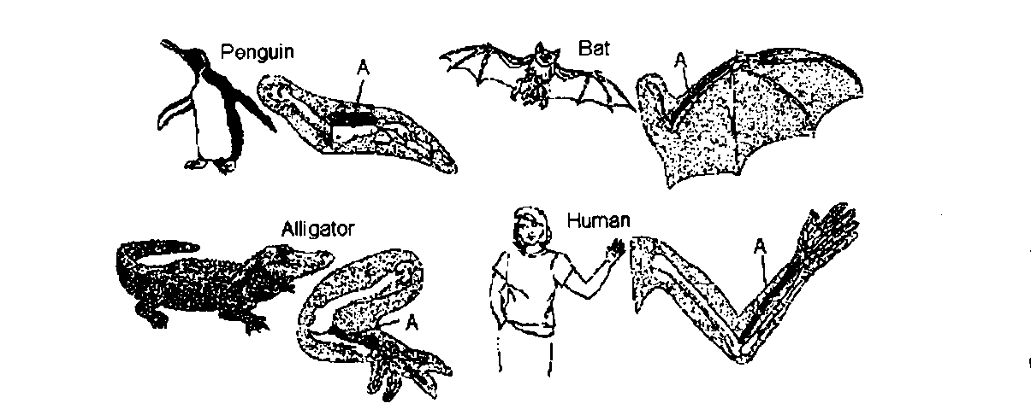

22. Refer to the illustration above. The bones labeled A are known as
a. | vestigial structures. | c. | homologous structures.
b. | sequential structures. | d. | fossil structures.

23. Refer to the illustration above. The similarity of these structures suggests that the organisms
a. | have a common ancestor. | c. | evolved slowly.
b. | all grow at different rates. | d. | live for a long time.

24. Refer to the illustration above. An analysis of DNA from these organisms would indicate that
a. | they have identical DNA.
b. | they all have pharyngeal pouches.
c. | their nucleotide sequences show many similarities.
d. | they all have the same number of chromosomes.

25. Why did Darwin think that the plants and animals of the Galápagos Islands were similar to those of the nearby coast of South America?

26. Natural selection as a result of reproduction could not occur without what?
a. | genetic variation in species. | c. | competition for unlimited resources.
b. | environmental changes. | d. | gradual warming of Earth.

The diagrams below represent bones in the limbs of fossil horses and modern horses.
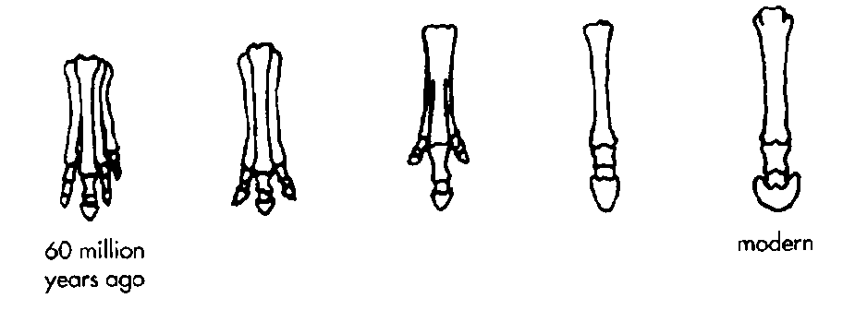

27. Refer to the illustration above. The fossils indicate that horse evolution probably has taken place
a. | rapidly.
b. | in only one place on Earth.
c. | gradually.
d. | five times by the process of punctuated equilibrium.

28. Structures that have reduced in size because they no longer serve an important function are called what?

______________________________.

29. Natural selection is the process by which
a. | the age of selected fossils is calculated.
b. | organisms with traits well suited to their environment survive and reproduce at a greater rate than less well-adapted organisms in the same environment.
c. | acquired traits are passed on from one generation to the next.
d. | All of the above

30. Which of the following describes a population?
a. | dogs and cats living in Austin, Texas
b. | four species of fish living in a pond
c. | dogwood trees in Middletown, Connecticut
d. | roses and tulips in a garden

31. New species form
a. | when subspecies diverge more and more.
b. | because of natural selection.
c. | when members of the same species become adapted to new environments.
d. | All of the above

32. List a vestigial structure in humans?

33. Which of the following DNA strands is most closely related to this strand of chimpanzee DNA?
Chimpanzee Strand: ATC TTA GGC CTA
a. | CAT TAT CAT TAT (Lemur) | c. | ATC TTA GGG CTA (Gorilla)
b. | GAT CTT CAG AAT (Spider Monkey) | d. | TAG AAT CCG GAT (Baboon)

Fill in the word(s)
Complete each sentence or statement.

34. Eyes in a blind salamander are an example of a type of organ known as ___________________________.

35. A species that has disappeared permanently is said to be _______________________________________.

36. Because they are inherited from a common ancestor, _________________________ structures are similar.

37. The process by which organisms with traits well suited to an environment survive and reproduce at a greater rate than organisms less suited for that environment is called ___________________________________.

38. Darwin’s observations of finches led him to believe that there was a close correlation between beak shape and __________________________________ source.

39. A change in species over time is called ___________________________________________.

40. Evolution that occurs at a constant rate is the hypothesis called ________________________________.

Unit 10 Study Guide Key (Ch. 13)
TRUE/FALSE
1. F-change rapidly to “over time”

2. F-change stays the same to “increases”

3. F-change doesn’t to “can”

4. F-take out “doesn’t”

5. F-change cannot to “can”

6. F-change vestigial to “homologous”
-
7. F-change extinction to “survival”

8. F-change against to “supporting”

9. F-change don’t to “can”
-
10. F-take out “only”

11. F-take out “doesn’t”

12. F-change different to “similar”

13. F-take out “do not”
MULTIPLE CHOICE
14. B

15. D

16. Asian vs African Elephants have different ear sizes depending on their climate.

17. A

18. Because they are the ones selected by the opposite mate because their characteristics are more desirable.

19. adaptation.

20. the shape changed to adapt to the changing food (seed) shape and texture.

21. divergence.

22. C

23. A

24. C
25. they looked similar to their ancestors which had migrated from South America to the Galápagos Islands.

26. A

27. C
28. vestigial.

29. B

30. C

31. D

32. the human tailbone

33. C
Fill in the word(s)
34. vestigial

35. extinct

36. homologous

37. natural selection

38. food
39. evolution

40. gradualism

