**What is an Ecosystem?**

Cues/ Pg #’s

**Ecosystems (Ch. 16)**

* **Ecology** --the study of the **interactions** of living organisms with one another and with their physical environment (soil, water, climate, etc)
* **Habitat**--the place where a particular population of a species **lives**. 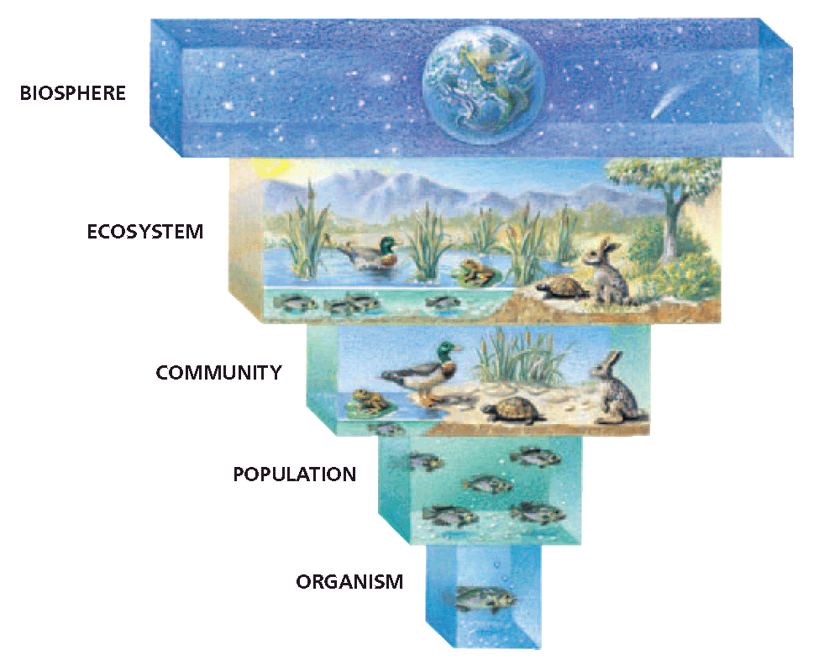

*

* + **Biosphere-** the whole earth including all biotic

and abiotic things (including outer space).

* + **Ecosystem-** All the biotic and abiotic things

living in one specific place (like a pond).

* + **Community**-Only the living (biotic) factors

living in one specific place.

* + **Population­-**all of the individuals of a specific

species (type) living in living in one specific place at

a specific time.

* + **Organism-**one individual in a population.

**Living vs Nonliving**

* **Living (Biotic)**
* Organisms that show all 6 characteristics of life are considered ALIVE or Living.
* Organisms which are dead still fit into this category.

Examples: tree bark, dead leaf, roadkill.

* **Biotic** is the term used to describe living and dead organisms.
* **Nonliving (Abiotic)**
* Organisms that do not show the 6 characteristics of life are considered nonliving.
* **Abiotic** is the term used to mean NOT/NEVER alive.

Examples: Water, bird nest, paper, rock, table.

**Summary**

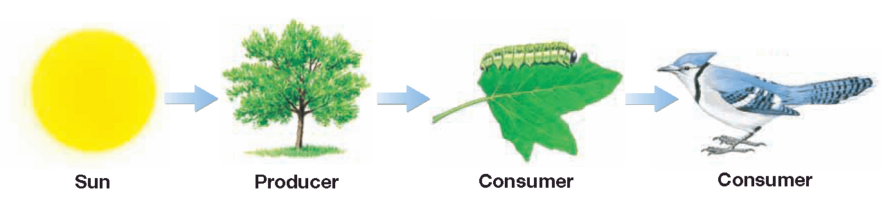**Energy Flow in Ecosystems (Ch. 16)**

Cues/ Pg #’s

* **Sun-**all organisms get their energy from the sun.

**Or** another form of heat-like hydrothermal vents.

* + This means that the sun is our primary energy source.
* **Primary Producers-** organisms that capture solar energy in storage molecules EX**:** plants, some bacteria, and algae.
  + The process of photosynthesis is how plants make energy using the sun.
  + The rate in which they make energy is called Primary Productivity.
* **Consumer-** organisms that consume (eat) plants or other organisms to obtain energy (they can’t make their own energy).
* Consumers can be broken down into **4 groups:** 
  + - **Herbivores—**can only eat/digest plants. EX: Horse, Cow, Deer

* + - **Carnivores—**can only eat/digest meat (other animals).

EX: Lion, Tiger, Wolf

* + - **Omnivores—**can eat both plants and animals.

EX: Bears, Humans, Birds, Scavengers

* + - **Detritivores**—these organisms feed on dead material and wastes, they decompose.EX: worms, fungi, some bacteria, maggots.
* **Food Chain-** the path or flow of energy from one organism to the next.
  + The arrows show the direction of energy moving INTO the organism’s stomach.
* **Food Web-** interconnected food chains. Arrows still show the direction of energy moving INTO the organism’s stomach.

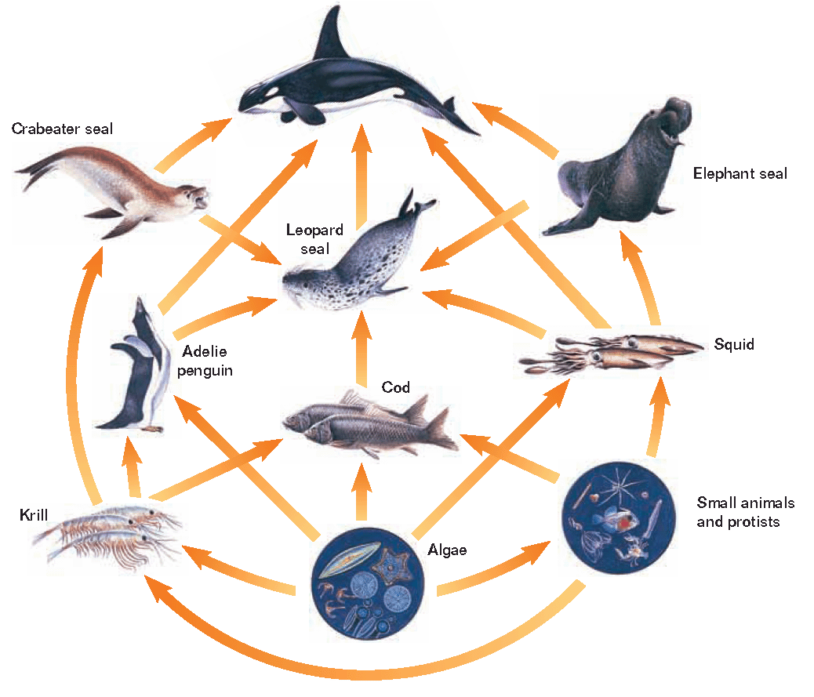

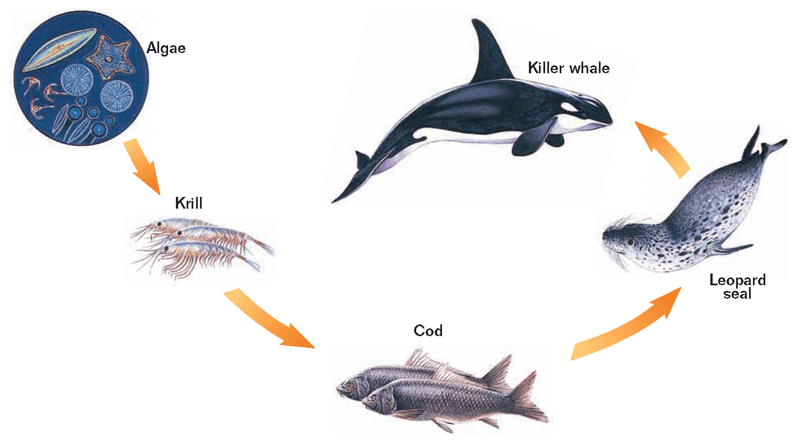

Cues/ Pg #’s

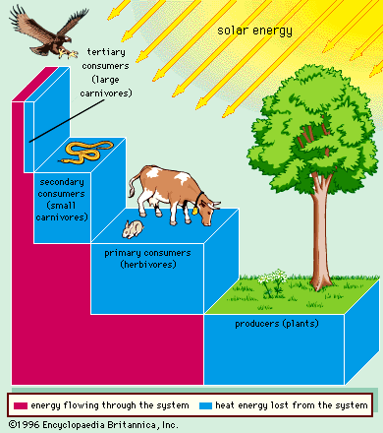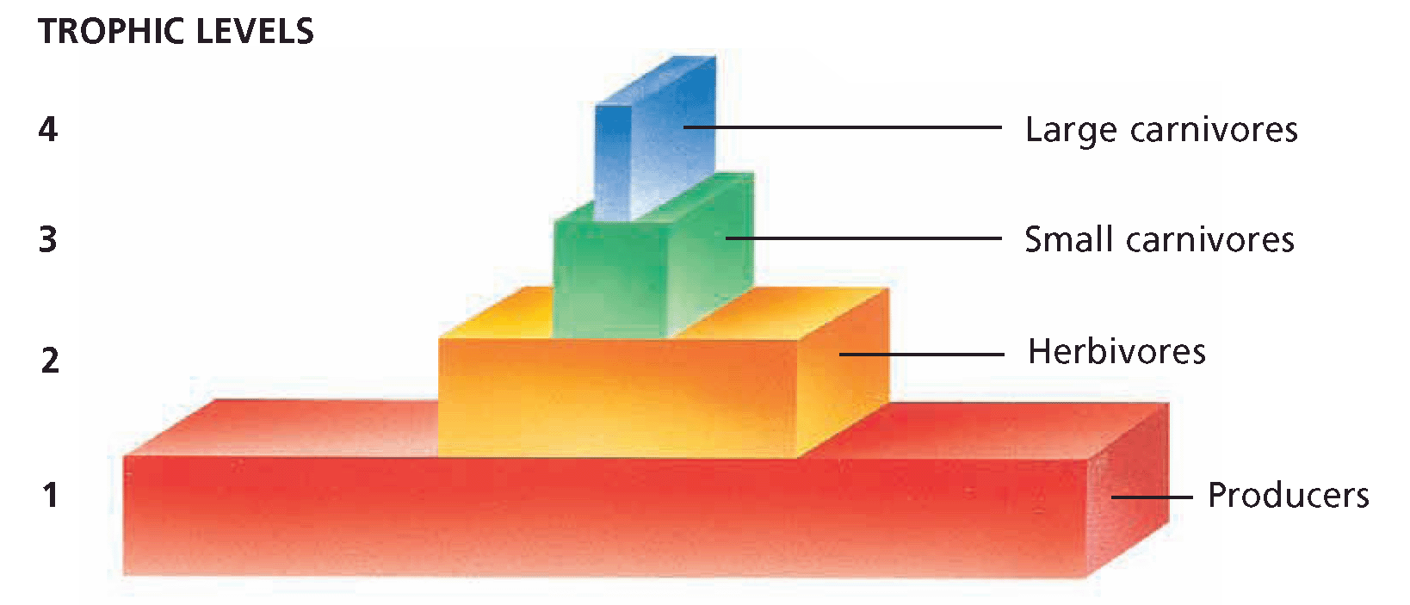

* **Trophic level-** feeding level in the flow of energy and nutrients from

primary producers to consumers, based on organism’s source of energy.

*

* First level—primary producers (plants)
* Second level—primary consumers (herbivores)
* 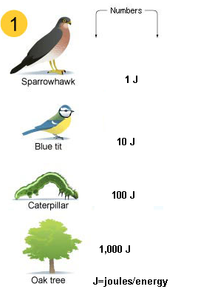Third level—secondary consumers (carnivores/omnivores)
* Fourth level—tertiary consumers (top carnivores)

**Conservation of Energy**

* **Energy Transfer-** in every energy transfer within an

ecosystem, energy is lost as heat.

* + Only 10% of the energy makes it to the next level
  + Loss of useful energy limits the number of levels

an ecosystem can support.

* + **Energy Pyramid**—pyramid of trophic levels that

occurs due to energy loss.

**Summary**

**Limitations on Trophic Levels (Ch. 16)**

Cues/ Pg #’s

* + The number of trophic levels is limited due to decreasing energy. The more levels you have, the less energy becomes available to the top carnivore.

The pictures below show how it is possible for humans to get more energy from eating plants (producers) than from eating meat (consumers).

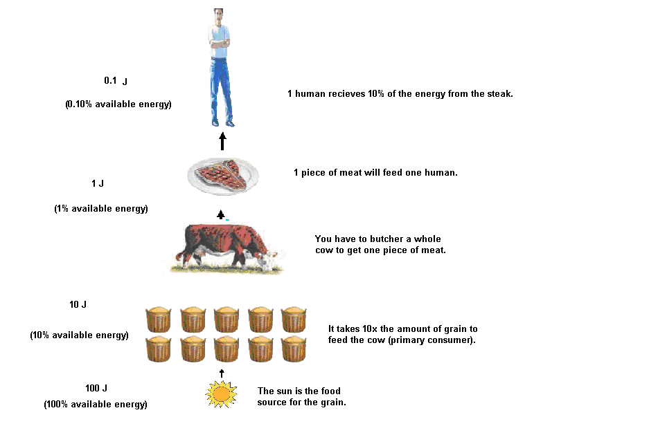

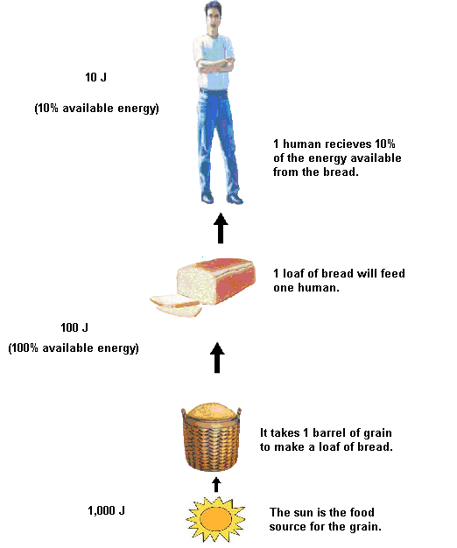

* + - * + Biomass—shows the total dry weight (energy stored in the tissues) of the

organisms at each level.

**Biodiversity (Ch. 16)**

* + Biodiversity is a measure of both the number of different species in a community (species richness) and the relative numbers of each of the species (how even).
  + The greater number of species in a plot of land had…..the greater the amount of plant material produced in that plot.

**Summary**

**How Organisms Interact (Ch. 17)**

* + MC900434399[1]**Symbiosis-**two or more species live together in a close, long-term association.*

3 types

* 1. Mutualism- BOTH organisms BENEFIT

Examples: A bird feeds on leeches and other scraps of

food in the crocodile’s mouth, the crocodile’s teeth are cleaned.



* 1. Parasitism –ONE organism BENEFITS but the other is HARMED.

Examples: A tick burrows into the cow’s skin to suck blood.



* 1. [](http://www.google.com/imgres?imgurl=http://images.sodahead.com/polls/000165492/polls_smiley_indifferent_3728_371204_answer_2_xlarge.jpeg&imgrefurl=http://www.sodahead.com/fun/do-you-think-trent-reznor-nin-is-sexy/question-165492/&usg=__wycVcIreu243yo3d4a5U8RONIN4=&h=350&w=350&sz=8&hl=en&start=42&zoom=1&tbnid=cWTc9l7aVdqnkM:&tbnh=120&tbnw=120&ei=RWtzTs_YAuiIsQKf5cWLBQ&prev=/search?q=smiley+idk&start=21&um=1&hl=en&sa=N&rls=com.microsoft:*&tbm=isch&um=1&itbs=1)Commensalism-ONE organism BENEFITS but the other not

harmed or helped (unaffected).

Examples: A skunk lives inside an abandoned woodchuck hole.

**How Competition Shapes Communities (Ch. 17)**

* + **Predator & Prey**
    - * + When one organism is hunted for food it is the Prey.

The animal that does the hunting is the Predator.

Examples: Bird/Worm (predator/Prey)

Cow/Grass (Predator/Prey).

* + **Plant Defenses Against Predators (Herbivores)**
    - * + Plants have tough leaves, spines, and thorns.
        + Defensive Chemicals-Plants also have defensive chemicals that help prevent/deter animals from eating them. They taste bad and are sometimes poisonous. These are called Secondary Compounds.

Example: Caffeine/Ants, Tobacco Plants/Nicotine

* + **Competition\***
    - * + When two species use the same resource, they participate

in a biological interaction called competition.

* + - * + Resources for which species compete include food, mates,

nesting sites, living space, light, mineral nutrients, and water.

* + - * + Competition occurs for resources in short supply.
        + Competition can limit how species use resources.

**Summary**

**Page 5**

**Interactions Among Species (Ch.17)**

Cues/ Pg #’s

* Some species adjust to one another over time and change according to what type of symbiosis works the best.

**Natural Selection (Ch. 15)**

* Natural selection is the term used to describe the process of species changing over time because of their response to the environment.
* **Adaptations**
  + **Phenotype** (physical appearance) of an organism can influence where they camouflage themselves, the better the camouflage the less likely they are to become eaten. The organisms that survive pass on their appearance to their offspring which helps the next generation survive longer.

**Examples:** Peppered Moths (insert picture here)

Arctic fox vs. Red fox- over time (depending on their environment) the fox’s fur changed color.

* + **Coevolution** two organisms are in a symbiotic relationship that allows them to change over time together (synchronous) in order to achieve a common goal.

**Examples:** Orchid Wasp. Certain plants have colors and patterns to attract specific pollinators (bugs, butterflies, bees).

* + **Mutations** changes in an organisms DNA (traits) due to many reasons; such as random mutations or environmental factors. Nature selects which organisms survive and these mutations remain. As these mutations build up in organisms, they affect the population. **Examples:** Bacteria becoming resistant to antibiotics. Bugs becoming immune to pesticides.
  + **Migration and Immigration**

Migration is when organisms leave an area in search of a density-dependent factor or to escape density-independent factors. Immigration is when organism join/enter an environment for the same reasons. Sometimes the landscape changes and doesn’t allow organisms to migrate back.

**Examples:** If a group of rabbits cross a river to find more food, but then a natural disaster separates those rabbits from the rest, overtime they will become two different populations and eventually different species.

**Summary Page 6**

Cues/ Pg #’s

* + **Niche** 
    - * + The role or job a species has is commonly called its **niche.** It is often described in terms of how the organism affects energy flow within the ecosystem in which it lives.
        + A niche may be described in terms of space utilization, food consumption, temperature range, requirements for moisture or mating, and other factors.
        + No two organisms can occupy the same niche at the same time.

A **realized niche** is the part of their entire niche that one organism is occupying at a specific time. *

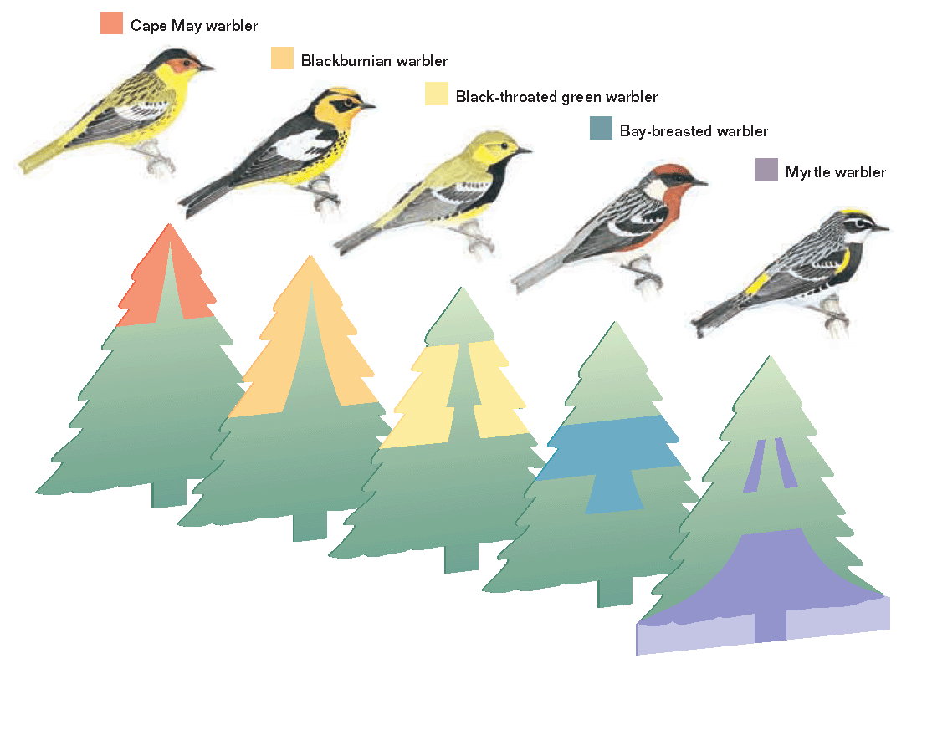

**Three Key Features of Populations (Ch. 15)**

* 1. **Population Size**- is the number of individuals in the entire population.
  2. **Population Density**- is the number of individuals that live in a specific area.
  3. **Population Dispersion**-the way the individuals of the population are arranged in space. There are 3 types of dispersion models: Random, Even, and Clumped.

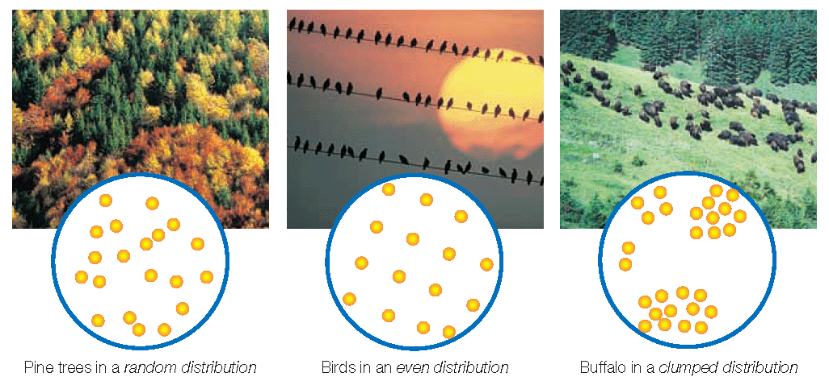

**Summary Page 7**

**How Populations Grow (Ch.15)**

Cues/ Pg #’s

* Populations grow when more individuals survive than die.
* Growth Rate= The difference between the birthrate and the death rate. This number can be positive or negative.

**Formula: Birthrate (#) – Death Rate (#)= Growth Rate**

**Factors Affecting Population Growth**

* The amount of individuals (population size) that an environment can support is called Carrying Capacity, often represented by the letter (K).

**Density-Dependent Factors**

* The abundance of resources like food and water depend on the number of individuals consuming them. These are called Density-Dependent factors.

Example: The # of predators depends on the # of prey (food source)

**K-strategists**

* K stands for Carrying Capacity. These type of organisms increase in population size according to the amount of resources available.

See the chart below:

|  |  |
| --- | --- |
| **Characteristics of K-strategist** | |
| **Growth** | **Slow Growth** |
| **Population Size** | **Small families** |
| **Environment** | **Predictable, stable** |
| **Reproductive Strategy** | **LATE IN LIFE**  **Reproduce 1-2 times per year producing few offspring, offspring are large in size** |
| **Offspring**  **Characteristics** | **Long life span, mature slowly, reach sexual maturity late in life.** |
| **Parental Care** | **Parents take care of offspring until they are mature enough to be on their own** |
| **Examples** | **Whales, humans, redwood trees** |

**Summary Page 8**

**Density-Independent Factors**

* When certain environment conditions (fire, drought, freeze,

tornado, seasonal change, abiotic factors) cause the entire population to die at the same rate, these conditions are called Density-Independent factors.

The number of individuals in the area has no effect on environmental conditions.

Example: Mosquitoes die in the winter because they can’t survive the extreme cold.

**r-strategists**

* r stands for Rapid Growth. These type of organisms grow exponentially when environmental conditions are just right.

See the chart below: *

|  |  |
| --- | --- |
| **Characteristics of r-strategist** | |
| **Growth** | **Exponential Growth (rapid)** |
| **Population Size** | **Temporarily Large then it drops quickly** |
| **Environment** | **Rapidly changing** |
| **Reproductive Strategy** | **RAPID**  **Reproduce several times per year, many offspring, offspring are small in size.** |
| **Offspring**  **Characteristics** | **Short life span, mature rapidly, reach sexual maturity when environmental conditions are right** |
| **Parental Care** | **Little or no parental care because offspring are born ready to survive.** |
| **Examples** | **Bacteria, cockroaches, mosquitoes** |

**Summary Page 9**

**How Populations Grow (Ch.15)**

Cues/ Pg #’s

**Logistic Growth**

* Some populations grow steadily and the numbers tend to decrease when resources like food and water run out. This is called Logistic Growth. *

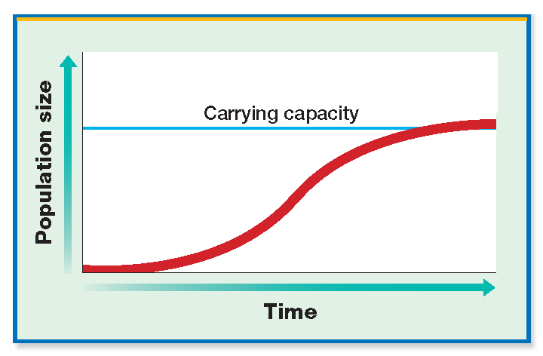

On a graph, with time on the x-axis and # of individuals on the y-axis it looks like a sideways “S”. This curve is due to density-dependent factors. (K-strategists)

**Exponential Growth**

Other populations grow exponentially (extremely fast/rapidly). The growth curve goes almost straight up, until the curve crashes. This is known as Exponential Growth.

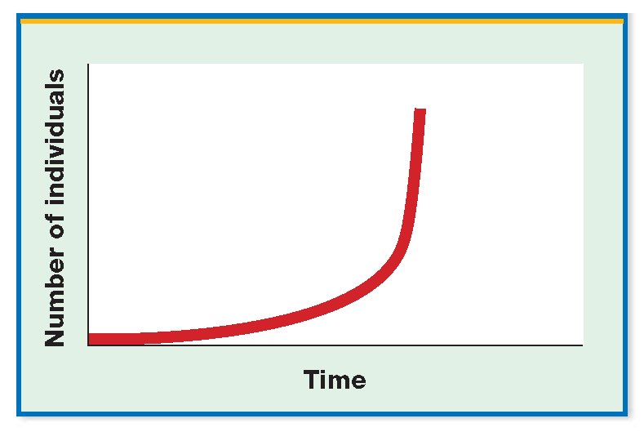

On a graph, with time on the x-axis and # of individuals on the y-axis it looks like a “J”. This curve is due to density-independent factors. (r-strategists)

**Summary Page 10**

Cues/ Pg #’s

|  |
| --- |
| **Population Growth Over Time** |
|  |

**Understanding Population Growth Over Time**

* Time periods A through B: Exponential growth (j-shaped curve).
* Time period C: Birth rate = Death rate (carrying capacity).
* Time period D: Death rate exceeds the birthrate (population crash).

**Ecosystems Change Over Time (Ch. 16-17) \***

* When a volcano forms a new island, a glacier recedes and exposes bare rock, or a fire burns all of the vegetation in an area, a new habitat is created.
* This change sets off a process of colonization and ecosystem development.
* The first organisms to live in a new habitat are small, fast-growing plants, called pioneer species.

**Example of a Pioneer Species: Lichen**

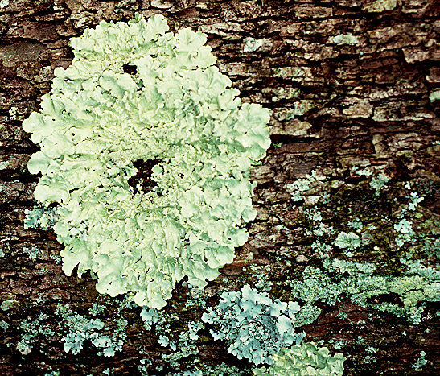Lichen is actually 2 organisms living mutually together. An alga attaches to a rock to use the sunlight for its energy/food source. Then a fungus decomposes the alga’s waste products. Together, their waste causes the rock to deteriorate and turn into soil. This soil allows new seeds to take root.

**Succession**

* When species replace themselves in an ecosystem it is called succession.
* Succession that occurs where plants have not grown before is called primary succession.

**Example: Glacier Bay**

* 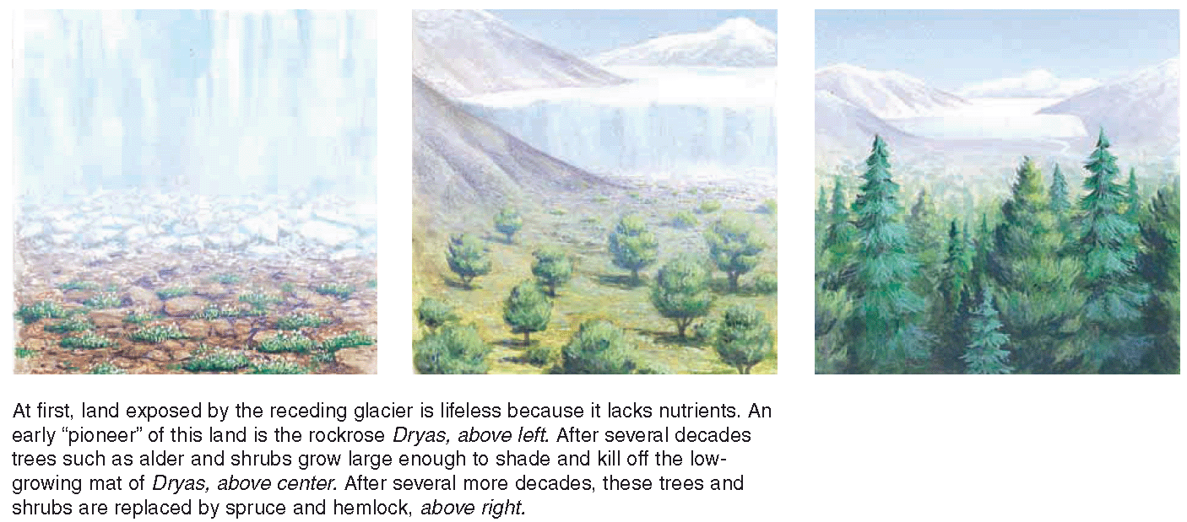Succession that occurs in areas where there has been previous growth, such as in abandoned fields or forest clearings, is called secondary succession.

**Summary Page 11**

**Biogeochemical Cycles (Ch. 16)\***

Cues/ Pg #’s

* In the environment certain biological substances/chemicals are continuously recycled and reused by nature. This process is known as a biogeochemical cycle.

**The 4 Biogeochemical cycles**

* The paths of water, carbon, nitrogen, and phosphorus pass from the nonliving environment to living organisms, and then back to the nonliving environment. These paths form closed circles. This is called **Conservation of Energy.**
* 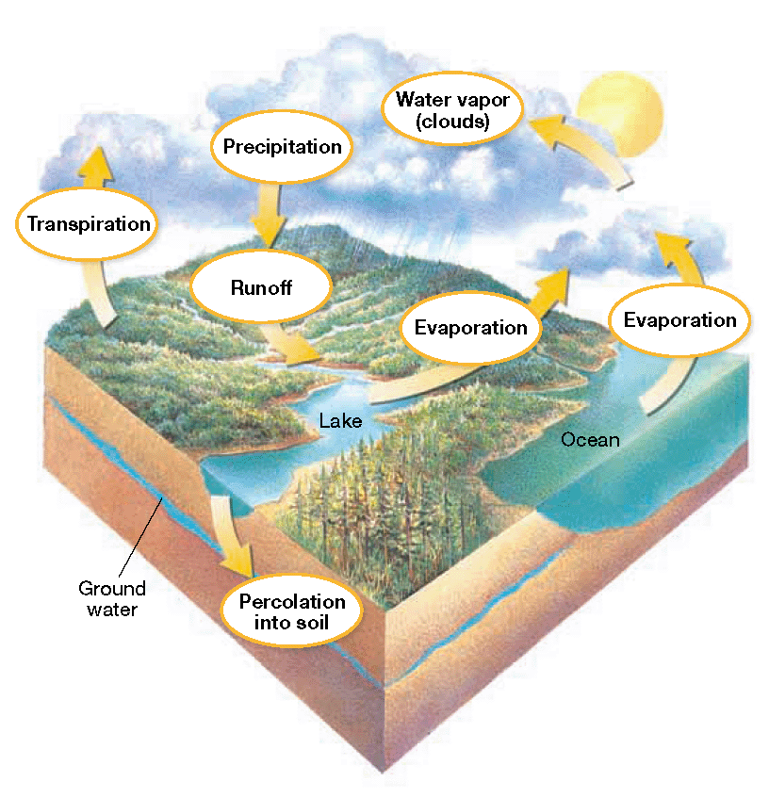In each biogeochemical cycle, a pathway forms when a substance enters living organisms such as trees from the atmosphere, water, or soil; stays for a time in the living organism; then returns to the nonliving environment.

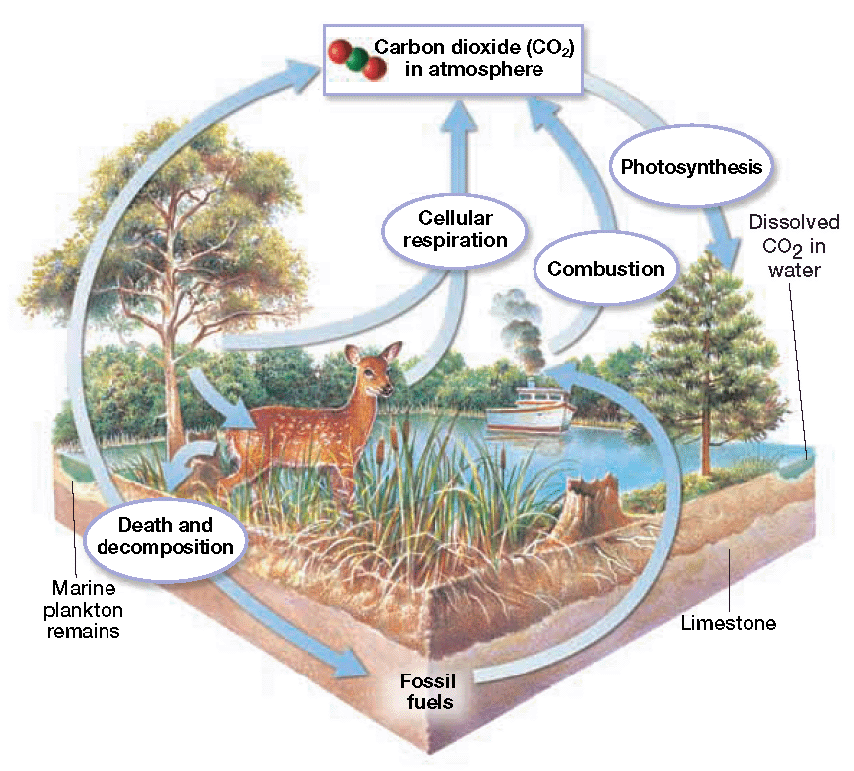

**Water Cycle Carbon Cycle**

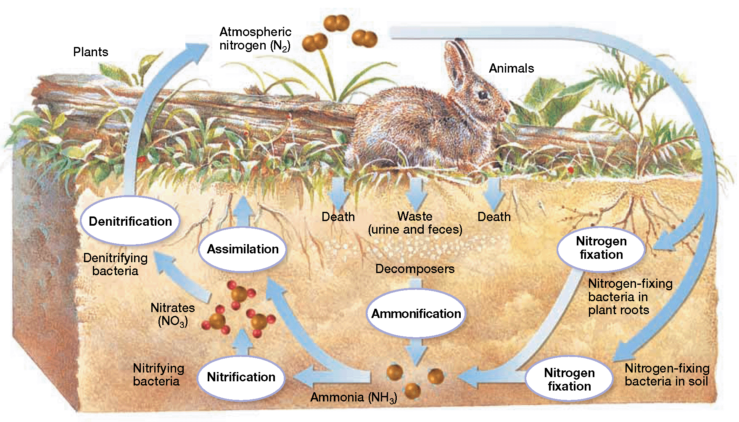

**Nitrogen & Phosphorus Cycle**

**Summary Page 12**