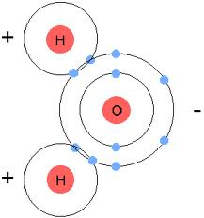**Unit 3 Biomolecule Notes**

Chapter 2 Section 2: Water and Solutions

**CUES**

**Water**

* A water molecule is composed of

two atoms of hydrogen and one atom of oxygen.

**Polarity**

* Being “polar” refers to having a positive and negative end. Water is polar because has two positive hydrogen on one side, and one negative oxygen on the other end.
* The polarity of water enables many substances to dissolve in water.
* When something dissolves well in water, we call it “hydrophilic”. Hydro=water and philic=loving
* Nonpolar molecules do not dissolve well in water.
* When something doesn’t dissolve in water, we call it “hydrophobic”. Hydro=water and phobic=fearing
* The inability of nonpolar molecules to dissolve in polar molecules is important to organisms.
* For example, the shape and function of cell membranes depend on the interaction of polar water with nonpolar membrane molecules.

**Properties of Water**

Water is important to living organisms because:

* + It acts as a buffer (surrounds cells) and helps organisms maintain body temperature.
  + It hydrates the bodies of all organisms.
  + It maintains protein shape that maintains cell turgidity.

Summary

Chapter 2 Section 2: Water and Solutions

**CUES**

**Turgidity**

* Turgidity is the state of being swollen. In biology, this refers to the pressure water puts on the inside of cells.
* When a plant’s stem is full of water is can stand upright because the water is putting pressure against the inside wall of the stem.
* However, when a plant loses turgidity the stems become limp and the plants fall over.

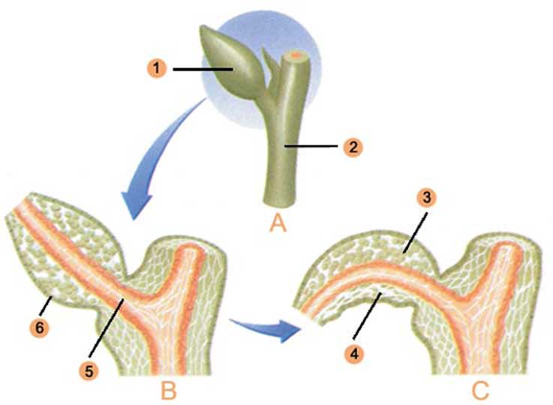

**Homeostasis**

* The state of being balanced, stable, or equal.
* Organisms use water to help cells maintain homeostasis.
* Humans maintain a constant internal temperature of 98.6°F (37.0°C) even though our surrounding temperature constantly changes. Humans are warm-blooded or “endothermic” which means “temperature within”.
* Reptiles must use their environment to maintain a constant internal temperature. They are “exothermic” which means “external heat”.

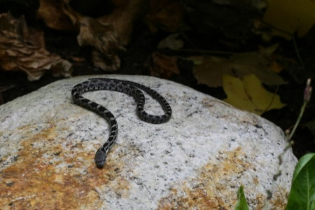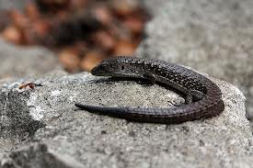

Summary

Chapter 2 Section 2: Water and Solutions

**CUES**

**Storage of Energy**

* Many organisms release excess heat through water evaporation (sweating and transpiration).

**Cohesion**

* Cohesion is an attraction between substances of the same kind.
* Because of cohesion, water and other liquids form thin films and drops.

**Surface Tension**

* Surface tension means that the molecules on the surface of the water are not surrounded by similar molecules on all sides, so they're being pulled only by cohesion from other molecules deep inside.
* These molecules cohere to each other strongly but adhere to the other medium weakly.
* Examples of this are the way that water beads up on waxy surfaces, such as leaves or waxed [cars](http://auto.howstuffworks.com/automobile.htm) and when a Water Strider is able to walk on water due to surface tension.

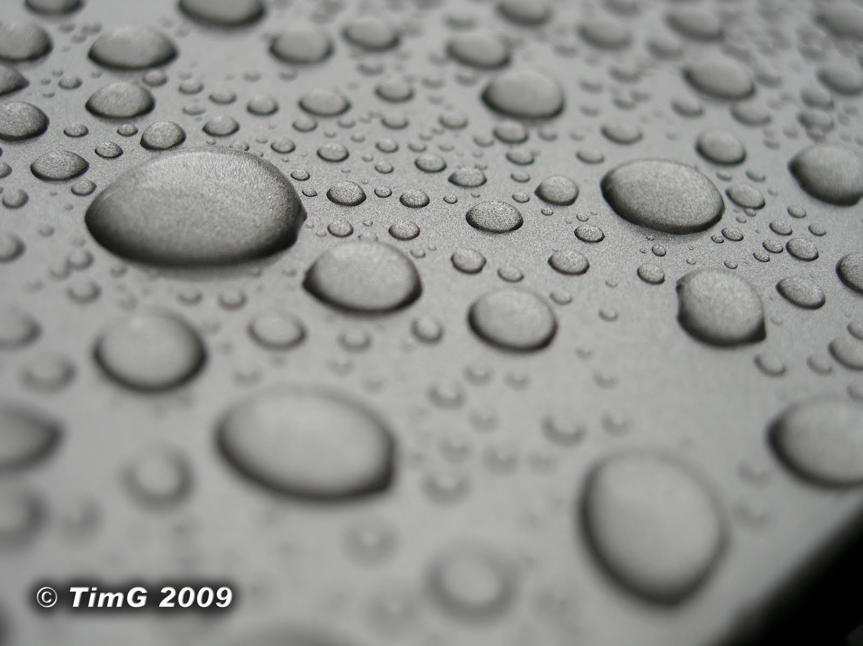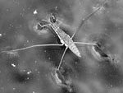

* Surface tension makes these water drops round so they cover the smallest possible surface area.

Summary

Chapter 2 Section 2: Water and Solutions

**CUES**

**Adhesion**

* Adhesionis an attraction between different substances.
* 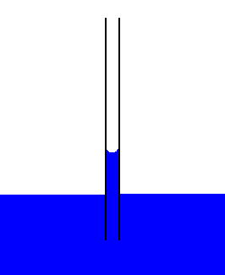Adhesion powers a process, called capillary action, in which water molecules move upward through a narrow tube, such as the stem of a plant.

**Mixtures**

* A solution is a mixture in which one or more substances are evenly distributed in another substance.
* A solvent is a liquid that dissolves other substances in it.
* A solute is the actual material or solid that will be dissolved.

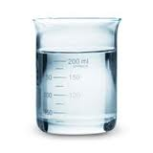**Solute Solvent**

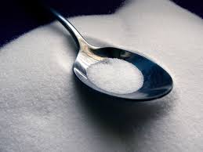

* Water as a “universal solvent” because it is able to dissolve many substances.

Summary

Chapter 2 Section 3: Chemistry of Cells (pg. 34)

**CUES**

**The 4 Organic Biomolecules (Carbon Compounds)**

* **Carbohydrates**
* **Lipids**
* **Proteins**
* **Nucleic Acids**

**1. Carbohydrates**

* Carbohydrates are organic compounds made of **carbon**, **hydrogen**, and **oxygen** atoms in the proportion of 1:2:1.
* Carbohydrates are a key source of **energy**, and they are found in most foods—especially fruits, vegetables, and grains.
* The building blocks of carbohydrates are **single** **sugars**, called monosaccharides**,** such as **glucose**, C6H12O6, and fructose**. (Most CARBS end in the suffix “OSE”)**
* Disaccharides are double sugars formed when two **monosaccharides** are joined.
* Sucrose, or common table sugar, is a disaccharide that consists of both **glucose** and **fructose**.
* Polysaccharides such as starch, are chains of **3** or more monosaccharides.

Carbon

Hydrogen

Oxygen

Carbohydrate=

Summary

Chapter 2 Section 3: Chemistry of Cells (pg. 35)

**CUES**

**2. Lipids**

* **Lipids** are non-polar molecules that are **NOT** soluble in **water**. (means they don’t dissolve). They include **fats**, phospholipids, steroids, and **waxes**.
* Fats are lipids that **store** energy.
* A typical fat contains three **fatty** acids bonded to a **glycerol** molecule backbone.
* In a **saturated** fatty acid, all of the carbon atoms in the chain are bonded to **two** hydrogen atoms.
* In an **unsaturated** fatty acid, some of the carbon atoms are linked by a “double” covalent bond, each with only **1** hydrogen atom, producing **kinks** in the molecule.

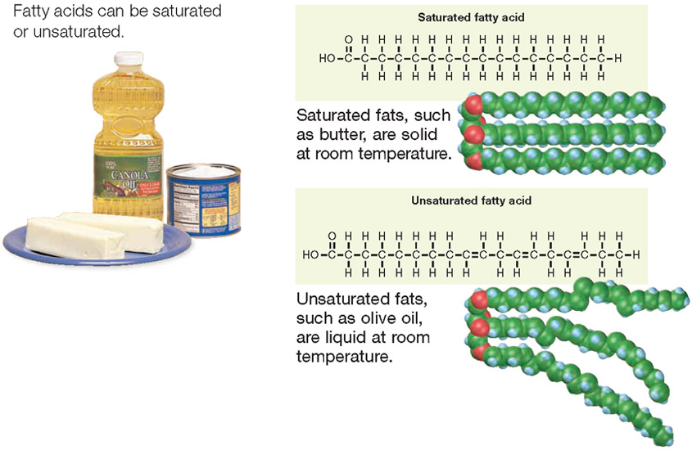

Summary

Chapter 2 Section 3: Chemistry of Cells (pg. 36)

**CUES**

**3. Proteins**

* A protein is a large molecule formed by linked smaller molecules called **amino** **acids**.
* Amino acids are the

building blocks of **proteins**.

* **20** different amino acids

are found in proteins.

* Some proteins are **enzymes** and promote

chemical reactions.

* Other proteins have important **structural** functions like collagen in your skin, your hair, and muscles.
* Other proteins help your body defend against **infection**. In your blood, the protein **hemoglobin** carries oxygen from your lungs to body tissues.

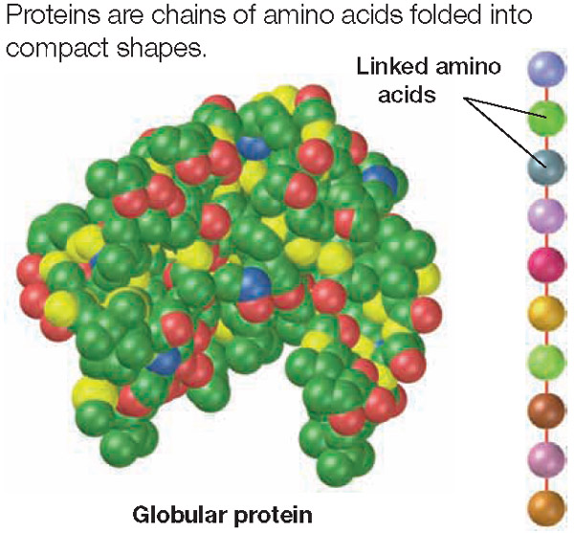

Summary

Chapter 2 Section 3: Chemistry of Cells (pg. 37)

**CUES**

**4. Nucleic Acids**

* A nucleic acid is a long chain of smaller molecules called **nucleotides**.
* A nucleotidehas three parts: a **sugar**, a base, and a **phosphate** group.
* The two types of Nucleic Acids are DNA and RNA.
* DNA stores **hereditary** information.

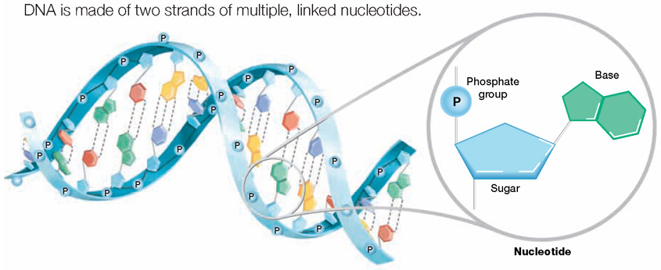

**ATP**

* ATP or adenosine tri-phosphate, is a single nucleotide with two extra **energy**-storing phosphate groups.
* When food molecules are **broken** down inside cells, some of the energy in the molecules is stored **temporarily** in ATP.

Summary

**CUES**

Section 4: Energy and Chemical Reactions (pgs. 38-39)

**Energy for Life Processes**

* Energy is the ability to **move** or change matter.
* Energy exists in many forms—including light, heat, chemical energy, **mechanical** energy, and **electrical** energy—and it can be converted from one form to another.
* Energy can be **stored** or **released** by chemical reactions.

**Energy in Chemical Reactions**

* In chemical reactions, energy is absorbed or released when chemical bonds are **broken** and new ones are **formed**.
* **Metabolism** is the term used to describe all of the chemical reactions that occur within an organism.

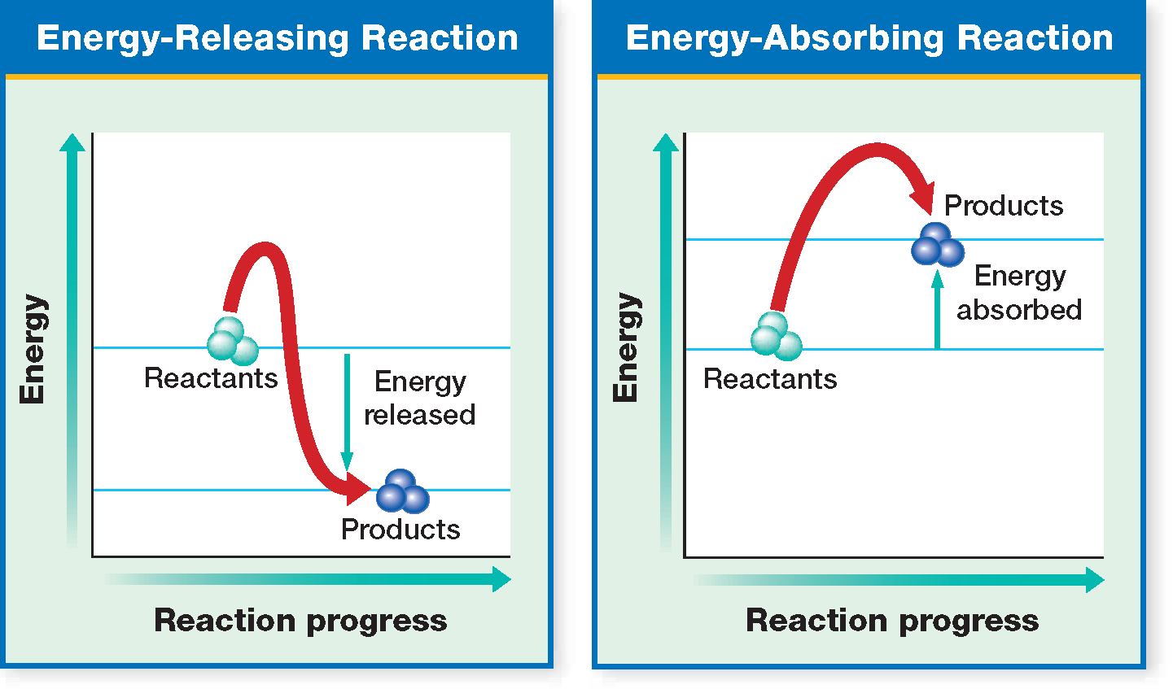

**Activation Energy**

* The energy needed to start

a chemical reaction is called

**activation** energy.

* Activation energy is simply

a chemical “push” that

**starts** a chemical

reaction.

* Even in a chemical reaction

that **releases** energy, activation energy must be supplied before the reaction can occur.

Summary

Section 4: Energy and Chemical Reactions (pgs. 40-41)

**CUES**

* Enzymesare substances that **increase** the **speed** of chemical reactions.
* Most enzymes are **proteins**.
* Enzymes are **catalysts**, which are substances that **reduce** the **activation** **energy** of a chemical reaction.
* An enzyme increases the speed of a chemical reaction by reducing the activation energy of the reaction.



**Enzyme Specificity**

* A substance on which an enzyme acts during a chemical reaction is called a **­­­­­substrate**.
* Enzymes act only on specific substrates.
* An enzyme’s **shape** determines its activity.
* Typically, an enzyme is a large protein with one or more deep **folds** on its surface. These folds form pockets calledactive **site**.

Summary

Section 4: Energy and Chemical Reactions (pg. 41-42)

**CUES**

**Enzyme Specificity**

* An enzyme acts only on a specific substrate because only that substrate **fits** into its active site.
* **Step 1** When an enzyme first attaches to a substrate, the enzyme’s shape **changes** slightly.
* **Step 2** At an active site, an enzyme and a substrate interact, **reducing** the reaction’s activation energy.
* **Step 3** The reaction is complete when **products** have formed.

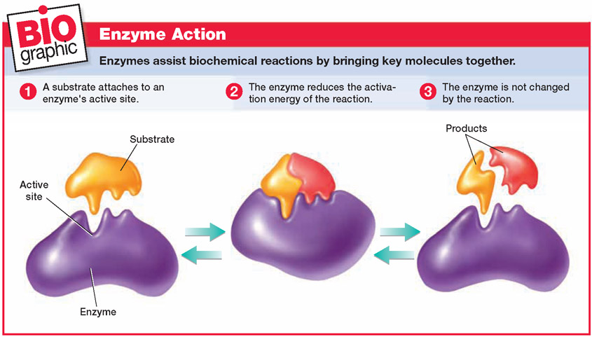**Factors in Enzyme Activity (p. 42)**

* Any factor that changes the shape of an enzyme can affect the enzyme’s **activity**.
* **Temperature** and pH value can alter an enzyme’s effectiveness.
* The enzymes that are active at any one time in a cell determine what happens in that cell.

Summary

Section 4: Energy and Chemical Reactions

**CUES**

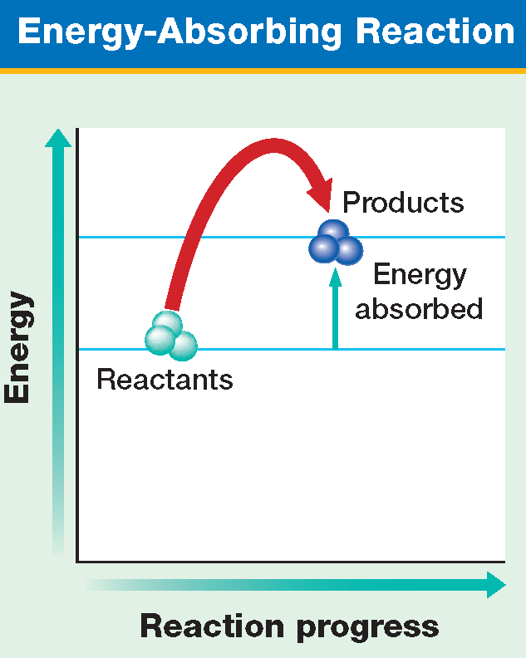**Endothermic Reactions**

Endo-**within**, thermic-temperature.

Endothermic reactions **absorb** (within) more energy than they start with.

Examples: Cold packs that you crack and they become cold.

**Exothermic Reactions**

Exo-**exit**, thermic-temperature

Exothermic reactions **release** more energy (heat and gas) than they start with.



Examples: Explosions, heat packs that you crack open.

Summary