Unit 4 Study Guide (Ch. 3) Cell Structure & Function
Name:
Hour: OPEN NOTE QUIZ

Fix the incorrect portion of the statement so that it is true.

1. Organelles allow prokaryotic cells to carry out specialized functions.
____________________________________________________________________________________

2. Flattened, membrane-bound sacs that “package and distribute” proteins are called mitochondria.
____________________________________________________________________________________

3. Vesicles contain digestive enzymes that break down proteins, nucleic acids, lipids, and carbohydrates.
____________________________________________________________________________________

4. The cells of animals are prokaryotic.
____________________________________________________________________________________

5. Mitochondria, chloroplasts, ribosomes, and the nucleus all contain their own DNA.
____________________________________________________________________________________

6. One difference between animal and plant cells is that only animals have chloroplasts.
____________________________________________________________________________________

7. One difference between animal and plant cells is that plants don’t have a cell wall.
____________________________________________________________________________________

Multiple Choice
Identify the choice that best completes the statement or answers the question.

____ 8. A protein that fits into the cell membrane
a. | has two polar ends that are attracted to water.
b. | has a specialized role.
c. | has a nonpolar middle section.
d. | All of the above

____ 9. Surface area is an important factor in limiting cell growth because
a. | the cell can burst if the membrane becomes too large.
b. | materials cannot enter the cell if it is too large.
c. | the cell may become too large to take in enough food and to remove enough wastes.
d. | waste products cannot leave the cell if it is too small.

____ 10. Elongated proteins that are on the surface of a cell and that identify the cell are called
a. | marker proteins.
b. | channel proteins.
c. | receptor proteins.
d. | enzymes.

____ 11. Most of the food and waste materials that move into and out of a cell pass through
a. | receptor proteins.
b. | marker proteins.
c. | enzymes.
d. | channel proteins.

____ 12. Phospholipids are molecules that
a. | contain phosphate.
b. | have nonpolar “tails” and polar “heads.”
c. | form the lipid bilayer of the cell membrane.
d. | All of the above

____ 13. To function most efficiently, a cell must be
a. | large.
b. | medium.
c. | small.
d. | any size.

____ 14. When the volume of a cell increases, its surface area
a. | increases at the same rate.
b. | remains the same.
c. | increases at a faster rate.
d. | increases at a slower rate.

____ 15. Which type of molecule forms a lipid bilayer within a cell membrane?
a. | protein
b. | phospholipid
c. | nucleic acid
d. | carbohydrate

____ 16. As cell size increases, the surface-area-to-volume ratio
a. | decreases.
b. | increases.
c. | increases then decreases.
d. | remains the same.

____ 17. What is one organelle that prokaryotes and plant cells share, but animal cells lack?
a. | Cell Membrane
b. | Cell Wall
c. | Flagella
d. | Chloroplasts

____ 18. What organelles makes and temporarily stores ATP?
a. | Chloroplast
b. | Mitochondria
c. | Ribosomes
d. | Nucleus

Completion
Complete each statement.

19. What organelles do plants have that animals don’t? (Hint: There are three.)
_______________________________________________________________________________________

20. Name three contrasting (differnent) things between prokaryotes and eukaryotes.
_______________________________________________________________________________________

21. Why does the cell membrane need channels?
_______________________________________________________________________________________

22. The drawing below is a very basic representation of a prokaryotic cell (A) and a eukaryotic cell (B). What is the easiest way to tell the difference?
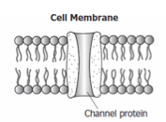
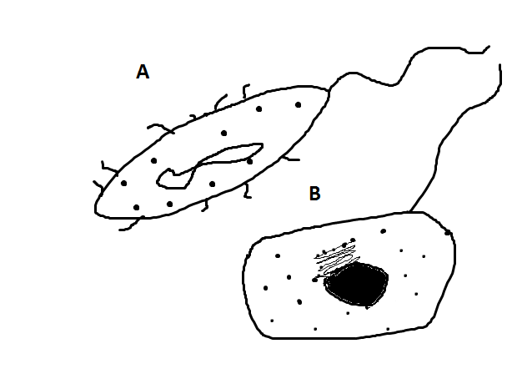

23. What are channel proteins used for in the cell membrane?

24. If a cell doesn’t have a flagella, what other part will it use for movement? Hint: These are used in the lining of our digestive track to move waste, in our reproductive system during menstruation, and in our lungs to move out dust particles.
_______________________________________________________________________________________

25. Scientists didn’t use to think that cells arise from existing cells. Explain the old theory of “spontaneous regeneration” and the “maggot” example used to prove that all cells arise from existing cells.
_______________________________________________________________________________________
_______________________________________________________________________________________
_______________________________________________________________________________________
_______________________________________________________________________________________
_______________________________________________________________________________________
_______________________________________________________________________________________

26.Label the following pictures as either prokaryote or eukaryote and label the nucleus (if any).

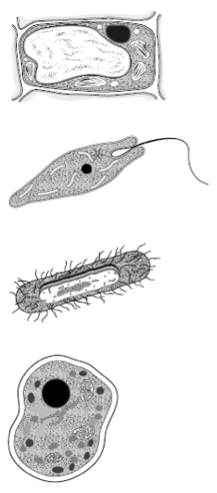

27. Label the parts of the cell (1-6).
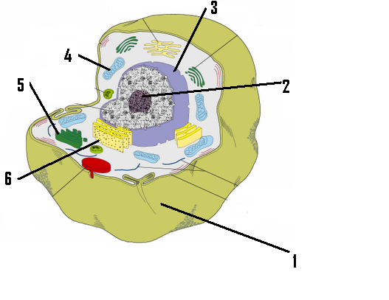

Describe the function of each part (from picture on previous page)
1.
2.
3.
4.
5.
6.

28. The following is a picture of a golgi. What do we call the name of the organelle that pinches off from it and is used as a sac to transport things around the cell and sometimes out? ______________________

29. The following picture is of the (cell membrane) phospholipid bilayer. What two things is it primarily composed of?
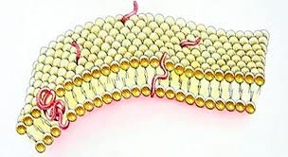

30. What is a synonym for energy? _______________

Unit 4 Study Guide (Ch. 3) Cell Structure & Function 2012-2013
Answer Section

TRUE/FALSE

1. F
change prokaryotic to eukaryotic

2. F
change mitochondria to golgi

3. F
change vesicles to lysosomes

4. F
change prokaryotic to eukaryotic

5. F
remove ribosomes

6. F
plants have chloroplasts

7. F
change plants to animals

MULTIPLE CHOICE

8. D
3.2.A

9. C
3.1.C

10. A
3.2.A

11. D
3.2.A

12. D
3.2.A

13. C
3.1.C

14. D
3.1.C

15. B
3.2.A

16. A
3.1.C

17. B

18. B

COMPLETION

19. chloroplasts
vacuoles
cell wall

20. Nucleus
Organelles
DNA

21. So that large particles have a way to go in and out.

22. Drawing B-eukaryotic cell has a nucleus
23. channel proteins
24. cilia
25. they thought that cells appeared out of nowhere like “magic”. They used two containers of raw meat to show that when you cover one the maggots don’t appear.
26. a-Eukaryote (nucleus dark circle)
b- Eukaryote (nucleus dark circle)
c-Prokaryotes (no nucleus)
d- Eukaryote (nucleus dark circle)

27. 1-Cell Membrane-controls what enters and leaves cell
2-Nucleus-stores hereditary info, controls/directs activities of the cell
3-Nuclear Envelop-controls what enters and leaves the nucleus
4-Mitochondria-makes/stores ATP
5-Golgi-packages/receives/distributes proteins
6-Rough E.R.-carries ribosomes to the nucleus and back

28. Vesicle
29. Proteins and Phospholipids
30. ATP

