**Unit 5 Notes: Cell Transport**

**The Cell Membrane (Ch. 3 Sect. 3)**

**CUES**

**The Cell Membrane**

* The fluidity of cell membranes is caused by **lipids**, which form the **foundation of membranes**.
* The lipids form a barrier that **separates the inside** of the cell from the **outside** of the cell.
* This selective **permeability** of the cell membrane determines which substances **enter and leave** the cell.

**The Cell Membrane as a Barrier**

* The selective permeability of the cell is mainly caused by the way **phospholipids interact with water**.
* In a cell membrane, the phospholipids are arranged in a **double layer** called a lipid bilayer.
* 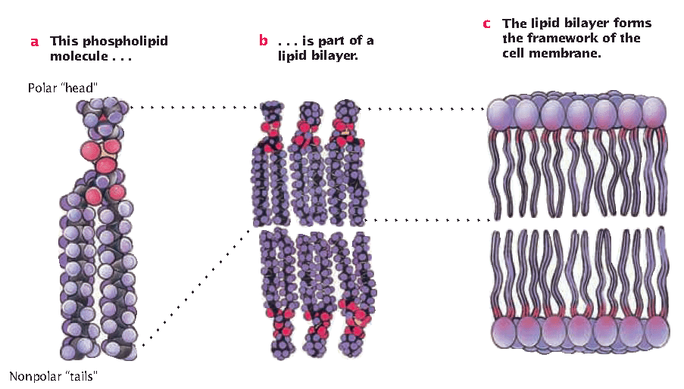The interior portion forms a non-polar zone that doesn’t allow large, polar, or ionic materials to pass through.
* A phospholipid’s “head” is polar (Loves Water)
* A phospholipid’s “tails” are non-polar (Hate Water)

Summary

**Types of Membrane Proteins**

**CUES**

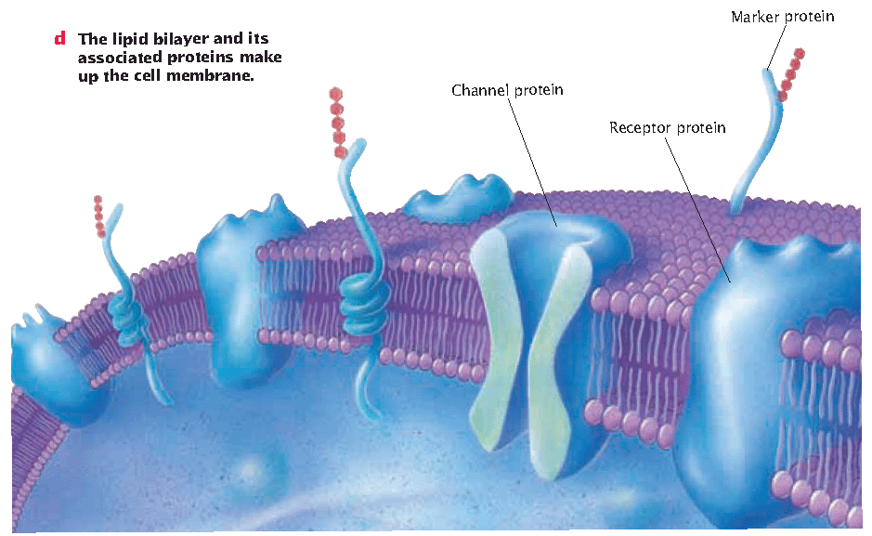

**1. Cell surface marker-** Carbohydrate chains help identify cell type. (Like Caller ID)

**2. Channel proteins-** Allows materials that can’t get directly through the bilayer in and out of the cell.

**3. Receptor Proteins**

* Proteins (B) (enzymes) in cell membrane that bind to signal molecules (A) (substrate).

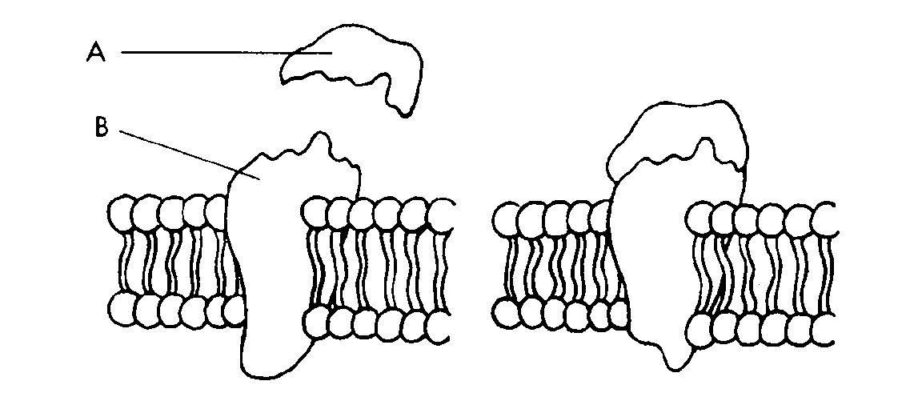

* This signal/message says one of three things:

1. Open channel proteins

(Open up)

2. Start a second message throughout the cell.

(Forward Text)

3. Act as an enzyme and speed up a reaction

in the cell (Hurry up)

Summary

**Types of** **Passive Transport (Ch. 4 sect. 1)**

**CUES**

**Passive Transport**

* + Transport of materials that does not require energy of a cell
  + Down concentration gradient = high to low
    - EX: Diffusion- solutes (substance)

Osmosis- water

**Turgidity**

* The pressure water puts on the inside of cells. Allows cells to be hydrated and to have a concentration gradient.

**Concentration Gradient**

* The difference in the concentration of a substance

over a distance.

* Based on random motions and collisions, molecules

move from regions of high concentration to regions

of low concentration.

**Equilibrium**

* The concentration of a substance is equal.

**Homeostasis**

* The process of maintaining equilibrium. Hydration, turgidity, and temperature all depend on homeostasis.

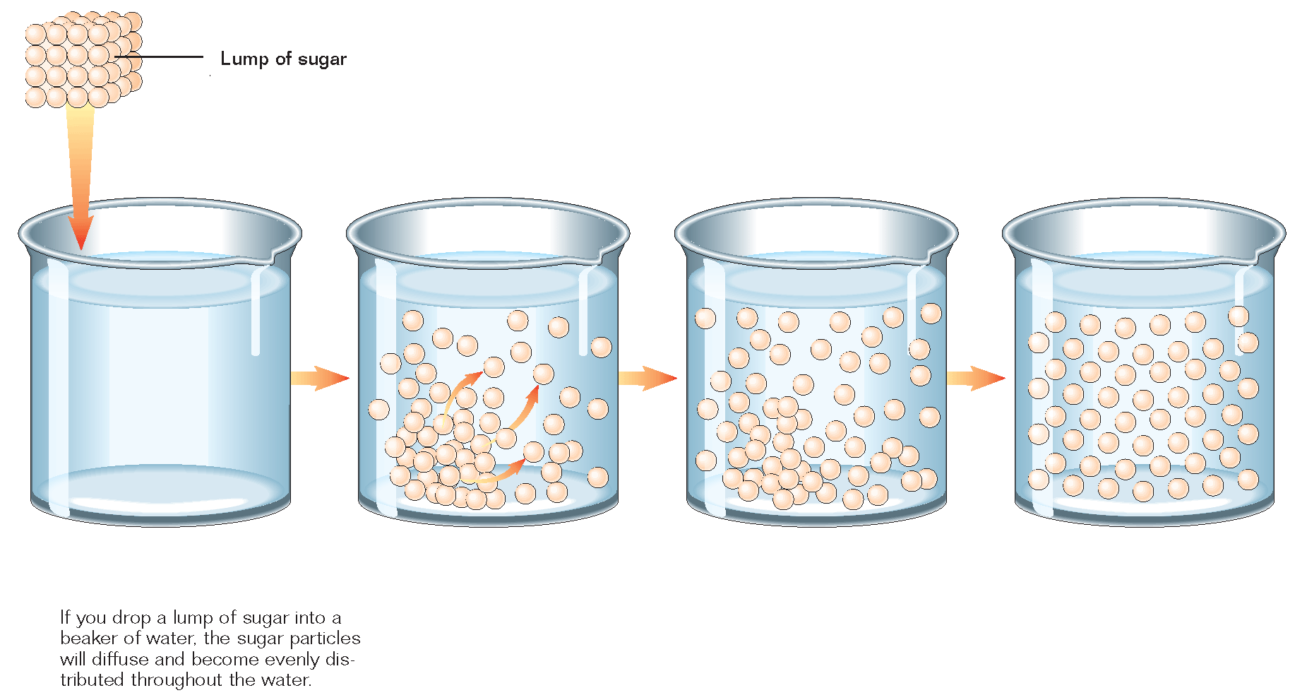The picture below shows diffusion resulting in equilibrium

**Types of** **Passive Transport**

**CUES**

**Diffusion (passive)**

* Movement of a material from an area of higher

concentration to lower concentration until

equilibrium is reached

* Substances move “down” the concentration gradient

* Does NOT require energy.
* Can occur across the cell membrane

**Simple Diffusion (passive)**

* + Movement of materials directly across the lipid

bilayer.

* For small, nonpolar molecules

**Facilitated Diffusion (passive)**

* Carrier proteins transport substances across.
* Membrane—no energy, down gradient.
* Molecules that can’t cross membrane polar, ions.

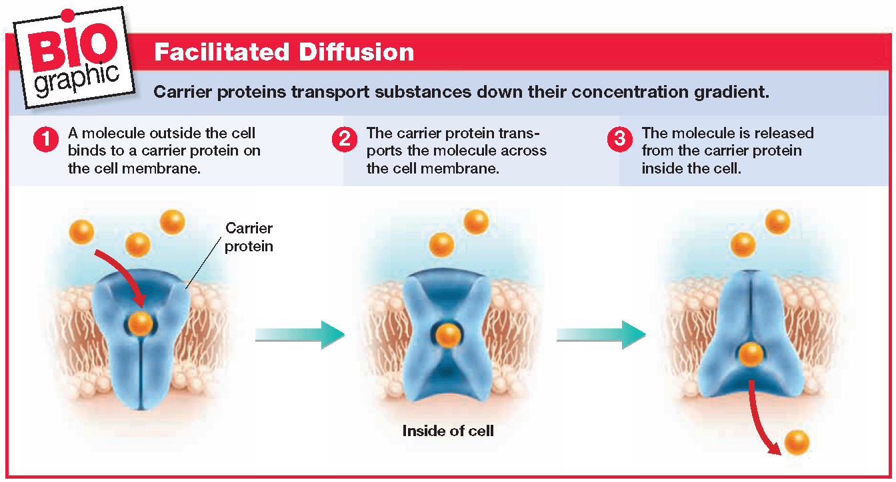

Summary

**Types of** **Passive Transport**

**Osmosis**

**CUES**

* Diffusion of water across a selectively permeable

membrane.

* Some water molecules don’t cross the membrane if

they are attracted to dissolved substances, only free

water moves (free water: not “attached” to a solute).

* Moves from areas of high to low (free water concentration).
* Does not require energy.

**Free Water**

Free water is water that is not attached to a solute.

If water is not “free” than it doesn’t get transported across the membrane as easily.

**Word Dissection/Definitions**

Iso- equal

Hyper- more

Hypo- less

Tonic- dissolved particles (like salt in water)

**Isotonic Solution**

* + Water moves in and out of the cell

at the ***same*** rate

* + Equal concentration of free water

Summary

**Types of** **Passive Transport**

**Hypertonic Solution**

* More solutes are in the solution (outside of cell)

**CUES**

* Water moves out of cell into the surrounding solution (cell shrinks)
* Fluid outside has more dissolved particles, less free water

**Hypotonic Solution**

* Less solutes are in the solution (outside of cell).
* Water moves in to the cell from the surrounding solution (cell swells or burst).
* Fluid outside has less dissolved particles, more free water.

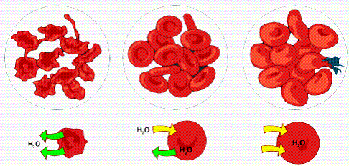

Hypertonic Isotonic Hypotonic

(Cells Shrink) (Cells stay same) (Cells Swell/Burst)

Summary

**CUES**

**Types of Active Transport (Ch. 4 sect. 2)**

**Active Transport**

* Transport of materials that requires energy of the cell.
* These materials are too large to fit through a channel.
* Energy comes from ATP.

(Adenosine Tri-phosphate)

A—P—P—P 🡪 A—P—P ≠ P

(Energy released when bond broken ≠)

* They move against concentration gradient.

low to high

* Uses carrier proteins or vesicles.
  + EX: Sodium Potassium Pump

Movement in Vesicles ­(Endo/Exocytosis)

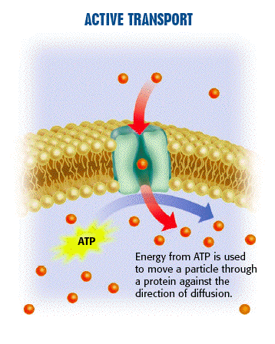

Summary

**Types of Active Transport**

**CUES**

**The Sodium Potassium Pump (active)**

* Sodium (Na+) and Potassim (K+) in our cells need to be regulated (homeostasis) to help with muscle contractions.
* The cell has to pump sodium and potassium at a 3:2 ratio. When 3 leave 2 can enter.
* When 3 Sodium get pumped out.

then 2 Potassium get pumped in.

* ATP powers the pump which is why it is a form of active transport.

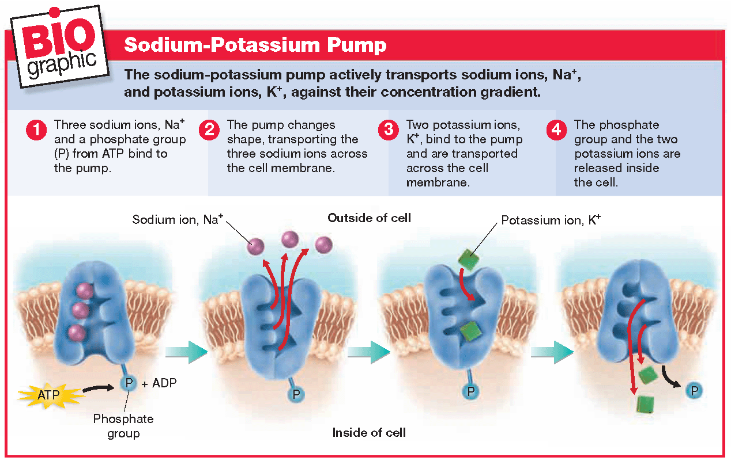

Summary

**Types of Active Transport**

**Movement in Vesicles (active)**

**CUES**

* Some molecules are too large to be transported by carrier proteins
* Cells move large molecules in vesicles
* 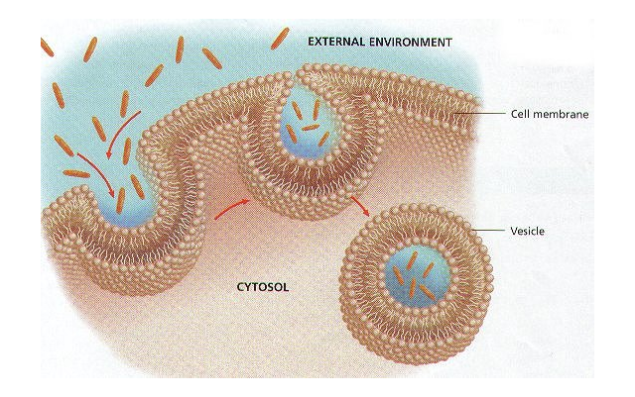To do this the membrane surrounding the vesicle merges with the cell membrane and lets particles enter or leave the cell.

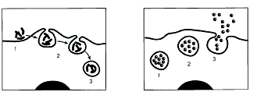

Endocytosis (Into Cell) Exocytosis (Out of Cell)

Summary

**Types of Active Transport**

**CUES**

**Endocytosis (active)**

* Movement of a substance INTO a cell by a vesicle
* Forms a pouch that pinches off inside cell

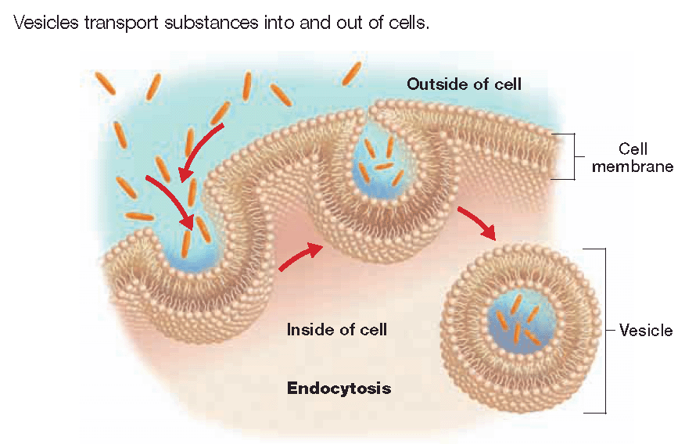

**Exocytosis (active)**

* Movement of a substance OUT of a cell by vesicle
* Vesicle fuses with membrane and contents are expelled/ejected.

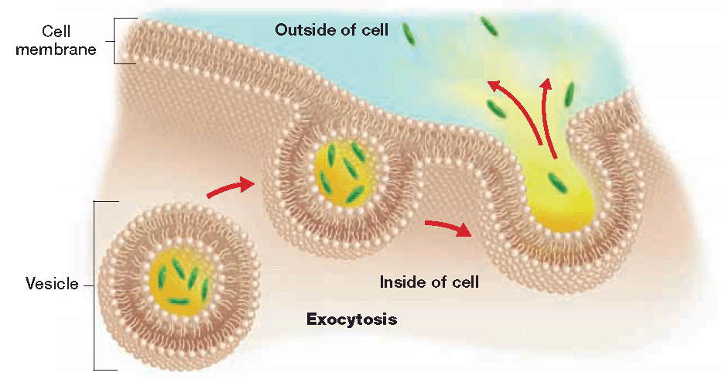

Summary