**Unit 5 Notes: Cell Transport**

**The Cell Membrane (Ch. 3 Sect.3)**

**CUES**

**The Cell Membrane**

* The fluidity of cell membranes is caused by ________ which form the ________________________________________.
* The lipids form a barrier that ___________________ of the cell from the ________________ of the cell.
* This selective _________________of the cell membrane determines which substances ___________________the cell.

**The Cell Membrane as a Barrier**

* The selective permeability of the cell is mainly caused by the way ___________________________________________.
* In a cell membrane, the phospholipids are arranged in a _________________________called a lipid bilayer.
* 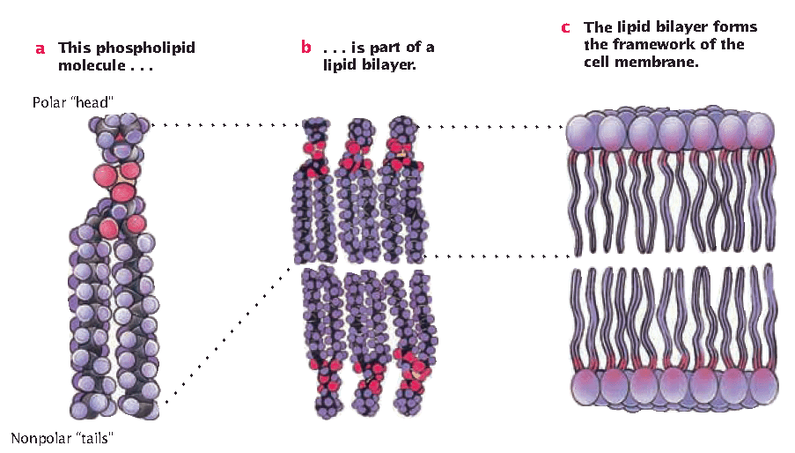The interior portion forms a non-polar zone that doesn’t allow large, polar, or ionic materials to pass through.
* A phospholipid’s “head” is polar (Loves Water)
* A phospholipid’s “tails” are non-polar (Hate Water)

Summary

**Types of Membrane Proteins**

**CUES**

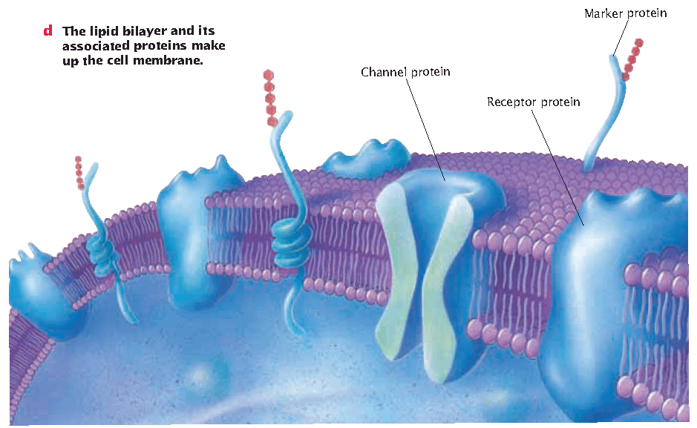

1. Cell surface marker- Carbohydrate chains help ___________ cell type. (___________________)

2. Channel proteins- Allows __________ that can’t get directly through the bilayer ________ of the cell.

3. Receptor Proteins

* Proteins (B) (_____________)in cell membrane that bind to signal molecules (A) (______________).

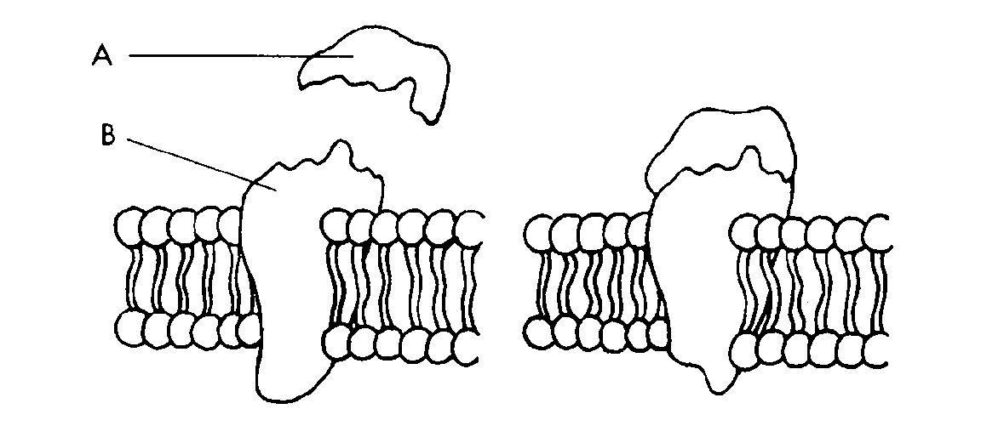

* This signal/message says one of three things:

1. ______________channel proteins

(Open up)

2. Start a _______________ throughout the cell.

(Forward Text)

3. Act as an _________________ a reaction

in the cell (Hurry up)

Summary

**Types of** **Passive Transport (Ch.4 sect. 1)**

**CUES**

**Passive Transport**

* + Transport of materials that ____________________

_____________ of a cell

* + ____________concentration gradient = high to low
    - EX: Diffusion-_____________

Osmosis-_____________

**Turgidity**

* The ___________water puts on the inside of cells. Allows cells to be hydrated and to have a concentration gradient.

**Concentration Gradient**

* The of a substance

over a distance.

* Based on _____________ and collisions, molecules

move from regions of ____ concentration to regions

of ______ concentration.

**Equilibrium**

* The _______________ of a substance is ________.

**Homeostasis**

* The process of _______________ equilibrium. Hydration, turgidity, and temperature all depend on homeostasis.

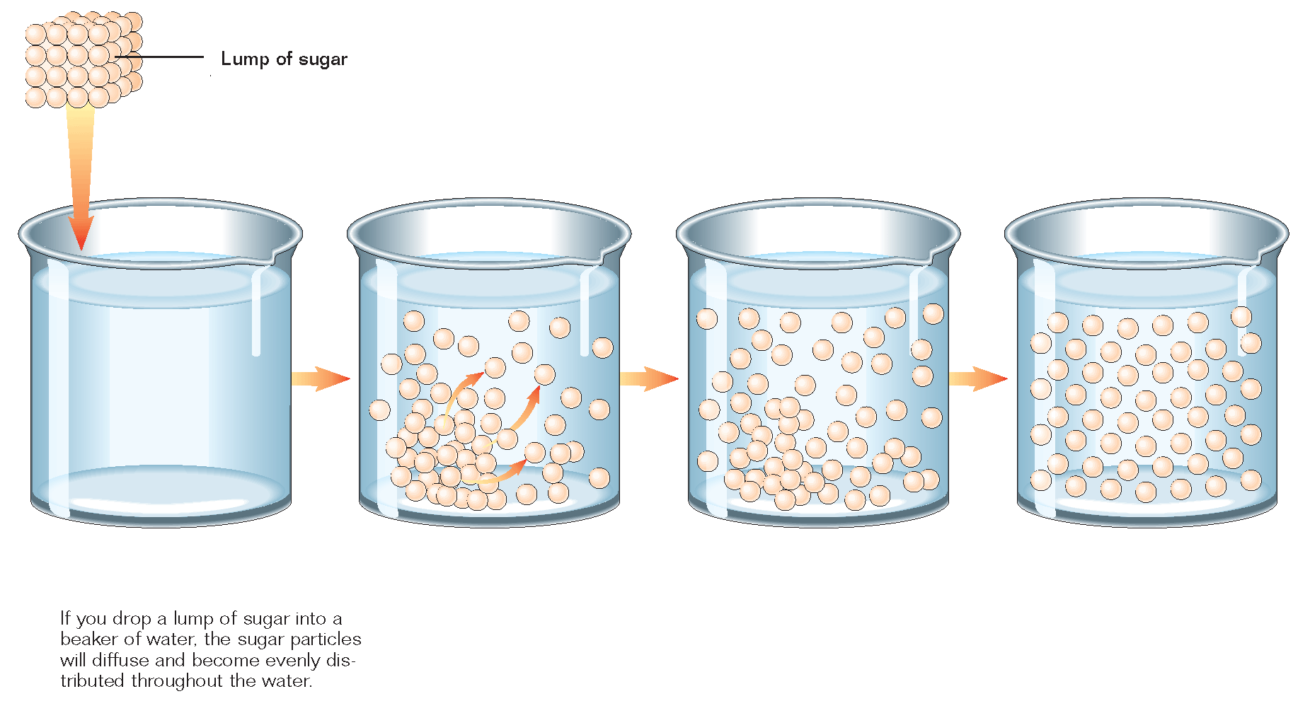The picture below shows diffusion resulting in equilibrium.

**Types of Passive Transport**

**CUES**

**Diffusion (passive)**

* Movement of a __________ from an area of higher

concentration to lower concentration until

__________________ is reached.

* Substances move _____ the concentration gradient.

* ­­­­­_____________________________.
* Can occur _____________the cell membrane.

**Simple Diffusion (passive)**

* + Movement of materials directly across the lipid

Bilayer.

* For _________________ molecules

**Facilitated Diffusion (passive)**

* ______________ transport __________________.
* Membrane—no energy, ___________ gradient.
* 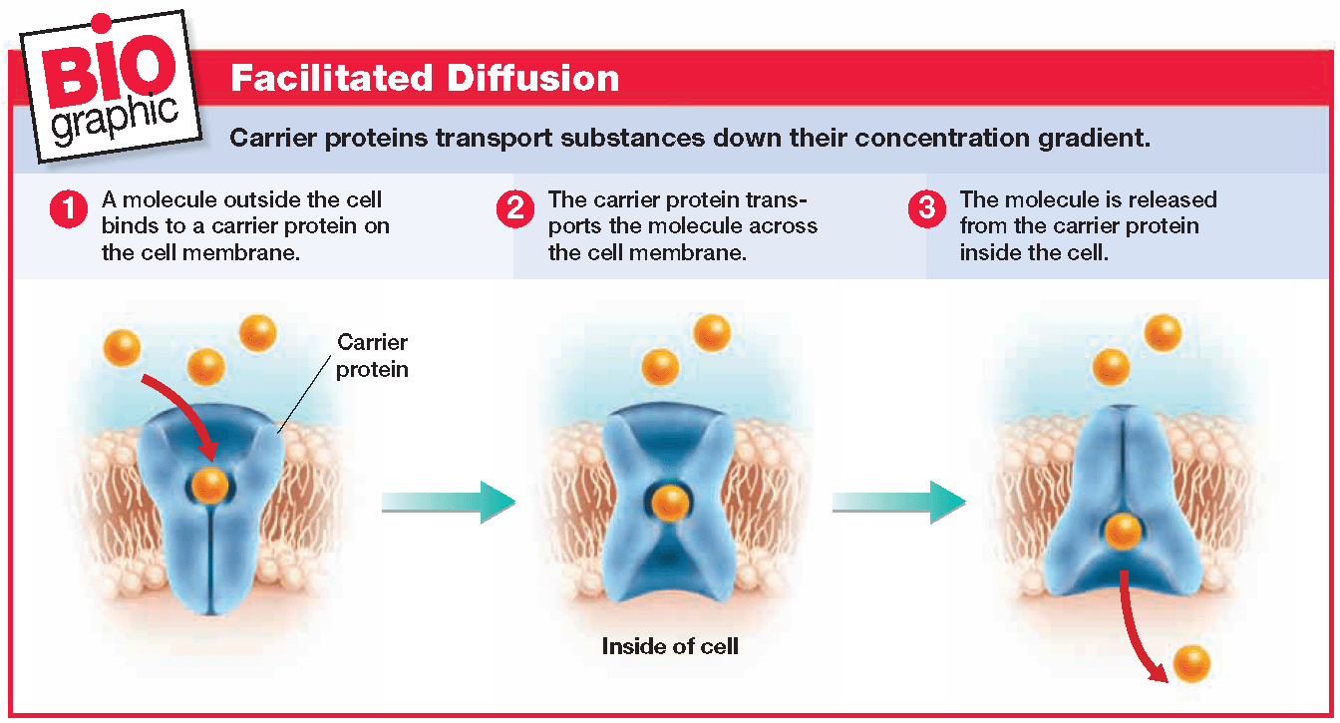Molecules that can’t cross membrane__________.

**Types of Passive Transport**

**CUES**

**Osmosis (passive)**

Diffusion of ________across a __________________

_________________________________.

* __________ molecules _______________________ if

they are _________ to dissolved substances, _______

_________________________.

* Moves from areas of _________ (free water concentration).
* ___________________________________________.

**Free Water**

Free water is water that____________________________.

If water is not “free” than it doesn’t get transported across the membrane as easily.

**Word Dissection/Definitions**

Iso- ___________

Hyper- ___________

Hypo- ___________

Tonic- ________________(like salt)

**Isotonic Solution**

* + Water moves ___________________ of the cell

at the ***_________***rate

* + _______________________________________.

Summary

**Types of Solutions**

**Hypertonic Solution**

**CUES**

* More solutes are in the solution (outside of cell).
* _________________ of cell into the surrounding solution (cell _________)
* Fluid outside has more dissolved particles, ­_____

_______________________________________.

**Hypotonic Solution**

* Less solutes are in the solution (outside of cell).
* _____________________ from the surrounding solution (cell __________ or burst).
* Fluid outside has less dissolved particles, ______

_______________________________________.

**Cells in different types of solutions:**

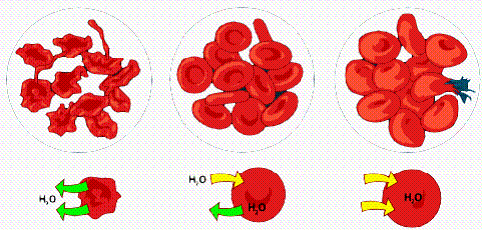

Hypertonic Isotonic Hypotonic

(Cells Shrink) (Cells stay same) (Cells Swell/Burst)

Summary

**Types of Active Transport (Ch.4 sect.2)**

**CUES**

**Active Transport**

* Transport of materials that __________________

_____________ of the cell.

* These materials are too ____________to fit through a channel.
* Energy comes from__________.

(Adenosine Tri-phosphate)

A—P—P—P 🡪 A—P—P ≠ P

(Energy released when bond broken ≠)

* They move __________ concentration gradient.

low to high

* ­­­­­­­­­Uses carrier____________________________.
  + EX: Sodium Potassium Pump (next page)

Movement in Vesicles (pg 8-9)

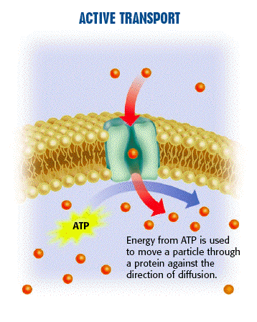

Summary

**Types of Active Transport**

**CUES**

**The Sodium Potassium Pump (active)**

* Sodium (Na+) and Potassium (K+) in our cells need to be regulated (__________________) to help with muscle contractions.
* The cell has to pump sodium and potassium at a 3:2 ratio. When 3 leave 2 can enter.
* When 3 Sodium get pumped ___________

then 2 Potassium get pumped __________.

* _____________________ powers the pump which is why it is a form of active transport.

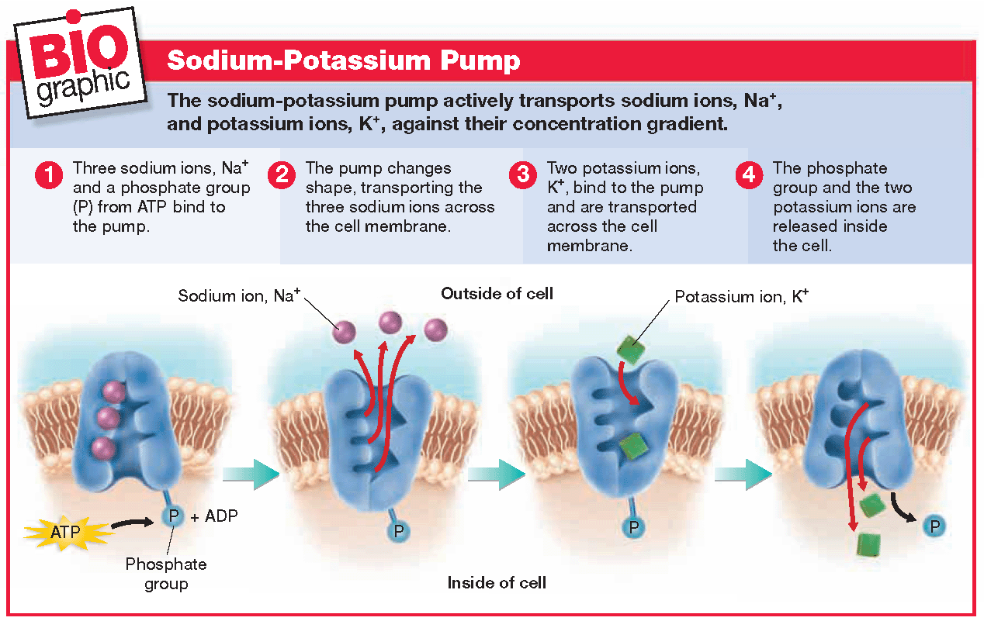

Summary

**Types of Active Transport**

**CUES**

**Movement in Vesicles (active)**

* Some molecules are ­­­­­­­­­_____________________ to be transported by carrier proteins.
* Cells move large molecules in ______________.
* To do this the membrane surrounding the vesicle ________________ with the cell membrane and lets particles enter or leave the cell.

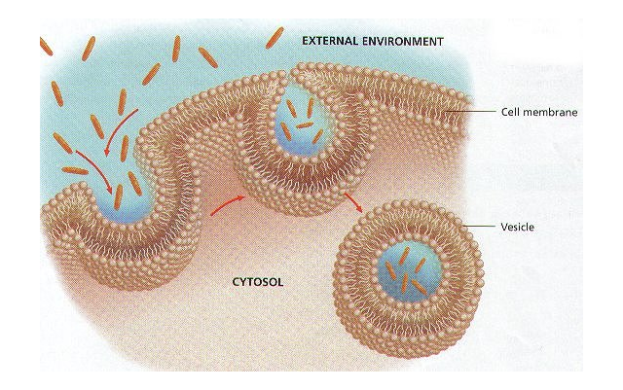

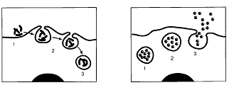

Endocytosis (__________) Exocytosis (___________)

Summary

**Active Transport**

**CUES**

**Endocytosis (active)**

* Movement of a substance ____ a cell by a vesicle
* Forms a _________ that ____________ inside cell.

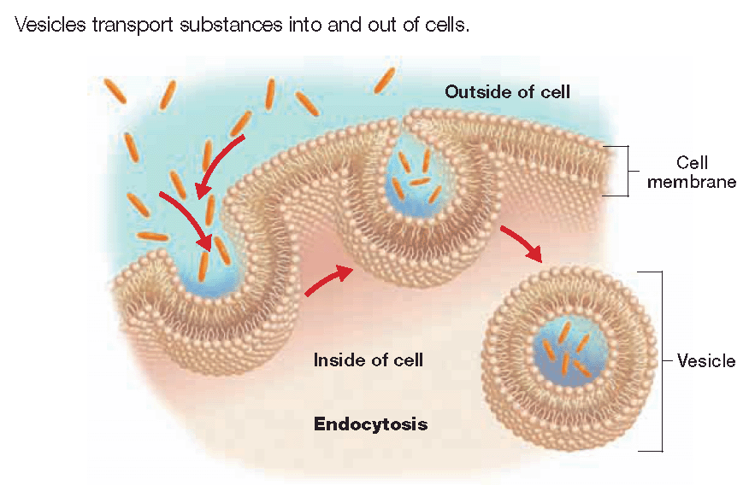

**Exocytosis (active)**

* Movement of a substance ______of a cell by vesicle
* __________________ with membrane and contents are ___________________.

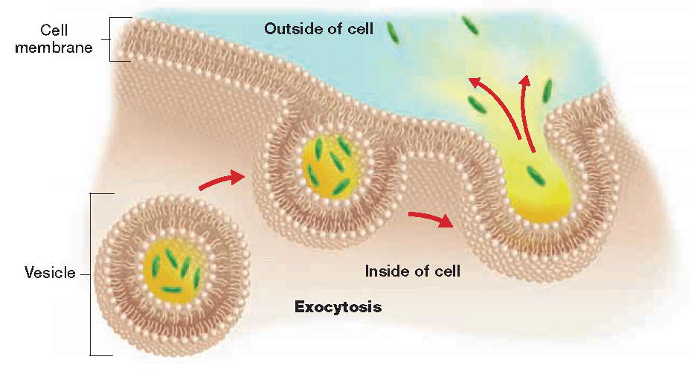

Summary