**Study Guide Unit 7: Mitosis & Meiosis (Ch. 6-7)**

**All statements are FALSE, please underline the incorrect portion of the statement and correct it below.**

1. In most animals, not including humans, meiosis produces sperm and egg cells.

________________________________________________________________________________________

2. Asexual reproduction provides for genetic diversity, the raw material for evolution.

________________________________________________________________________________________

3. Human sperm and egg cells have 21 chromosomes.

________________________________________________________________________________________

4. Meiosis produces six nuclei that have different chromosome numbers from the parent cell.

________________________________________________________________________________________

5. In sexual reproduction, two parents each form diploid cells, which join to form offspring.

________________________________________________________________________________________

6. During cytokinesis in plant cells, the cell is pinched in half by a belt of protein threads.

________________________________________________________________________________________

7. The fusion of two diploid gametes produces a haploid zygote.

________________________________________________________________________________________

8. Cells spend most of their lifetime in cytokinesis.

________________________________________________________________________________________

9. Gametes are diploid so that when fertilization occurs, the resulting zygote will have the characteristic number of chromosomes for that species.

________________________________________________________________________________________

10. A male can produce sperm with only Y chromosomes.

________________________________________________________________________________________

11. A karyotype is a type of gene.

________________________________________________________________________________________

12. After mitosis and cytokinesis, each new cell has a half set of the parent cells’ chromosomes.

________________________________________________________________________________________

13. In asexual reproduction, two parents each pass copies of all of their chromosomes to their offspring.

________________________________________________________________________________________

14. Binary fission is a form of sexual reproduction in bacteria.

________________________________________________________________________________________

15. Spindle fibers don’t move chromosomes during cell division.

________________________________________________________________________________________

16. The function of the cell cycle is to produce daughter cells with only ½ the DNA as the original cell. ________________________________________________________________________________________

17. If an intestinal cell of a grasshopper contained 12 chromosomes, its sperm would also contain 12.

________________________________________________________________________________________

18. An animal cell forms a cell plate during cytokinesis but plant cells pinch in half and pull apart.

________________________________________________________________________________________

**Multiple Choice**

*Identify the letter of the choice that best completes the statement or answers the question.*

1. Sexual and asexual reproduction are alike in that
   1. they both involve two parents.
   2. they both require meiosis to complete the reproductive cycle.
   3. they can both occur in multicellular organisms.
   4. they both give rise to genetically distinct offspring.
2. Which statement *best* describes the primary function of DNA replication?
3. to ensure daughter cells have a complete copy of the DNA
4. to prevent mutations from occurring in cells
5. to provide genetic variation within specific organisms
6. to allow prokaryotic cells to undergo meiosis
7. Which process *most* contributes to genetic variation in a population?
8. crossing over during meiosis
9. chromosome replication during mitosis
10. cytokinesis during cellular division
11. duplication of chromosomes in asexual reproduction
12. Why is it advantageous for a bacteria to reproduce asexually?
13. genetic variation
14. rapid growth
15. both A and B
16. none of the above
17. What is the result of the fertilization of an egg?
18. It restores the diploid number of chromosomes.
19. It deletes polypeptide chains in the chromosomes.
20. It gives offspring more chromosomes that the parents.
21. It gives offspring fewer chromosomes that the parents.

____ 24. The difference between Prophase and Prophase I is that

|  |  |
| --- | --- |
| a. | Cytokinesis occurs in Prophase but not in Prophase I |
| b. | The nuclear envelop reforms in Prophase I |
| c. | In Prophase I, crossing-over can occur |
| d. | Spindles move chromosomes to opposite poles in Prophase I |

____ 25. The exchange of segments of DNA between the members of a pair of chromosomes

|  |  |
| --- | --- |
| a. | acts as a source of variations within a species. |
| b. | ensures that variations within a species never occur. |
| c. | always produces genetic disorders. |
| d. | is called trisomy. |

____ 26. The difference between Telophase and Telophase II is that

|  |  |
| --- | --- |
| a. | In Telophase begins with haploid cells |
| b. | You end with four diploid cells after Telophase |
| c. | Telophase II results in haploid cells |
| d. | Cytokinesis doesn’t occur in Telophase II |

____ 27. The phase of mitosis that is characterized by the arrangement of all chromosomes along the equator of the cell is called

|  |  |  |  |
| --- | --- | --- | --- |
| a. | telophase. | c. | prophase. |
| b. | anaphase. | d. | metaphase. |

____ 28. Which of the following does *not* provide new genetic combinations?

|  |  |  |  |
| --- | --- | --- | --- |
| a. | random fertilization | c. | independent assortment |
| b. | cytokinesis | d. | crossing-over |
|  |  |  |  |

____ 29. When crossing-over takes place, chromosomes

|  |  |
| --- | --- |
| a. | double in number. |
| b. | exchange corresponding segments of DNA. |
| c. | decrease in number. |
| d. | produce new genes. |

____ 30. As a result of mitosis, each of the two new cells produced from the parent cell during cytokinesis (3.3.C.a)

|  |  |
| --- | --- |
| a. | receives a few chromosomes from the parent cell. |
| b. | receives exactly half the chromosomes from the parent cell. |
| c. | receives an exact copy of all the chromosomes present in the parent cell. |
| d. | donates a chromosome to the parent cell. |

**Matching**

**Use the choices below to fill in the best possible answer for questions 47-55**

|  |  |  |  |
| --- | --- | --- | --- |
| a. | Interphase | f. | Telophase |
| b. | Prophase | g. | S |
| c. | G1 | h. | Anaphase |
| d. | Metaphase | i. | Cytokinesis |
| e. | G2 |

____ 31. Chromosomes line up in the middle

____ 32. The cell grows for the first time

____ 33. The nuclear envelop reforms around the two new nuclei

____ 34. DNA is copied (synthesized)

____ 35. The cytoplasm pinches in half

____ 36. The cell spends 90% of its life in the phase

____ 37. Chromosomes get pulled to opposite sides of the cell by the spindle

____ 38. The nuclear envelop opens and dissolves, the spindle is formed

____ 39. The cell grows a second time and organelles are copied

**Use the choices below to fill in the best possible answer for questions 40-47**

|  |  |  |  |
| --- | --- | --- | --- |
| a. | Chromosomes | e. | 23 |
| b. | XX | f. | Mitosis |
| c. | 46 | g. | Chromatid |
| d. | XY | h. | Meiosis |

____ 40. A female’s sex chromosmes.

____ 41. The number of chromosomes in humans.

____ 42. Two exact copies of DNA that make up a chromosomes.

____ 43. Human gametes contain this number of chromosomes.

____ 44. A cell’s nucleus divides.

____ 45. Haploid cells are produced.

____ 46. These contain thousands of genes.

____ 47. A male’s sex chromosomes.

**Short Answer**

48. In humans, which person’s gametes determine the sex of the child? Why?

49. Out of the total 46 chromosomes, how many of them are related to determining the sex of a child? _________ and how many have nothing to do with determining the sex (autosomes) ________?

50. If an intestinal cell in a grasshopper contains 24 chromosomes, a grasshopper sperm cell would contain _________ chromosomes.

51. The function of the cell cycle is to produce daughter cells that

52. In a diploid cell containing 10 chromosomes, meiosis results in the formation of daughter

cells containing _________chromosomes

53. A human zygote (fertilized egg), like most other human cells, contains 46 chromosomes. How many chromosomes does a zygote receive from the mother? _____________________

54. What are some advantages of asexual reproduction?

55. What are some population advantages of sexual reproduction?

**Problem**

56. 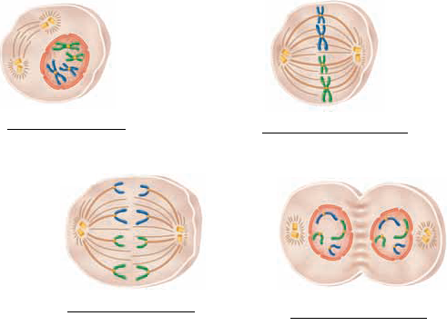

Please label each picture with the correct phase of Mitosis (Prophase, Metaphase, Anaphase, or Telophase)

57. 

Next to each description, write Figure A or B.

Mitosis ________

Meiosis________

Diploid cells produced________

Haploid cells produced________

Sperm or Egg produced________

Somatic cells produced________

Daughter Cells identical to parent________

Daughter Cells contain 1/2 of parents chromosomes________

Crossing over can occur________

Two divisions of nucleus________

Nucleus divdes once________

Gametes produced________

58. 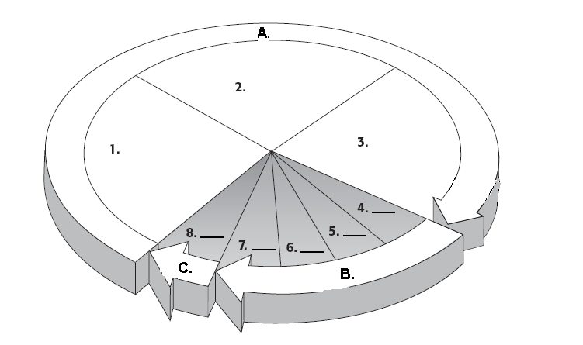

Please number the following words according to where they should go on the diagram:

_______G1 _______Cytokinesis _______G2 _______S phase

_______Prophase _______Anaphase _______Metaphase _______Telophase

59. Label the following pictures: Mitosis, Cloning, Haploid cells being produced.



60. Please label each picture with the correct description (some used more than once).

Yeast, Gametes, Hydra, Bacteria, Sexual reproduction, budding, binary fission, clones.



**Study Guide Unit 5: Mitosis & Meiosis (Ch. 6-7)**

**Answer Section**

**TRUE/FALSE**

1. F

take out not

2. F

Change asexual to sexual

3. F

Change 21 to 23

4. F

change six to four

5. F

Change diploid to haploid

6. F

change plant to animal

7. F

change haploid and diploid

8. F

change cytokinesis to interphase

9. F

Change diploid to haploid

10. F

X or Y

11. F

change type of gene to picture of chromosomes arranged by size

12. F

change half to complete or (full)

13. F

change all to half

14. F

change sexual to asexual

15. F

remove don’t

16. F

Change “only ½” to “a full set of”

17. F

change “its sperm would have 12” to “its sperm would have 6”

18. F

switch animal and plant

**MULTIPLE CHOICE**

19. C

20. A

21. A

22. B

23. A

24. C

25. A

26. C

27. D

28. B

29. B

30. C

**MATCHING**

31. D

32. C

33. F

34. G

35. I

36. A

37. H

38. B

39. E

40. B

41. C

42. G

43. E

44. F

45. H

46. A

47. D

**SHORT ANSWER**

48. Because the female’s egg can only be an X but a male’s sperm can be either an X or a Y.

49. 2 (the X and Y chromosomes) and 44 autosomes

50. 12

51. identical to parent

52. 5

53. 23

54. exponential growth, many generations, no parental care, less energy used.

55. genetic variation, offspring stronger than parents

**PROBLEM**

56. 3=Prophase

2=Metaphase

1=Anaphase

4=Telophase

57. Mitosis Figure B

Meiosis Figure A

Diploid cells produced Figure B

Haploid cells produced Figure A

Sperm or Egg produced Figure A

Somatic cells produced Figure B

Daughter Cells identical to parent Figure B

Daughter Cells contain 1/2 of parents chromosomes Figure A

Crossing over can occur Figure A

Two divisions of nucleus Figure A

Nucleus divdes once Figure B

Gametes produced Figure A

58. G1=1

Cytokinesis=8

G2=3

S=2

Prophase=4

Anaphase=6

Metaphase=5

Telophase=7

59. 1) Cloning

2) Mitosis

3 & 4) Haploid

60. A) Gametes, sexual reproduction

B) Hydra, budding, clones

C) Bacteria, binary fission, clones

D)Yeast, budding, clones